**ROOM BOOKING SYSTEM**

**Submitted in the partial fulfillment of the**

**Requirement for the Bachelor degree**

**In**

**Computer Application**

**By**

**Rashmi M.**

**12/ucsb/527**

**&**

**TahaTahseen R.**

**12/ucsb/540**

**December 2014 - March 2015**



**StellaMarisCollege (Autonomous)**

**17, Cathedral Road,**

**Chennai-600086.**

**STELLAMARISCOLLEGE**

**(Autonomous)**

**17, Cathedral Road,**

**Chennai-600086.**

**Bachelor degree**

**In**

**Computer Application**

**(Affiliated to University Of Madras)**

**[](http://www.stellamariscollege.org/aboutus/emblem.asp)**

**BONAFIDE CERTIFICATE**

**This is to certify that this is a bonafide record of the project done by**

**Rashmi M.**

**&**

**TahaTahseen R.**

**On**

**Room Booking System**

**At**

**Stella Maris College**

**December 2014 - March 2015**

**This project was done by them in the partial fulfillment of the**

**requirements for the Bachelor degree in Computer Application**

**Head of Department Internal Guide External Examiner**

**ACKNOWLEDGEMENT**

The satisfaction and elation that accompany the successful completion of any task would be incomplete, without the mention of the people who have made it a possibility. It is our great privilege to express the gratitude and respect all those who have guided and inspired us during the course of the project work.

Firstly we would like to thank the Almighty for helping us throughout this project. He provided us the strength to complete this project successfully.

We convey our sincere thanks **to Dr. Sr. Jasintha Quadrus f.m.m, M.Sc., M.Phil. M.S., PhD**. Principal of Stella Maris College for completing our project. We convey our heartily gratitude and sincere thanks to **Mrs.U.JeyaPriya, M.C.A., M.Phil.** Head of computer science department for giving us the opportunity to take up a project for developing a package on ‘ROOM BOOKING SYSTEM’

We take the immense pleasure in thanking our faculty **Ms.A.R.Charulatha, M.Sc., M.Phil.**Our project guide, for giving us proper guidance, timely advice, support and for her active involvement throughout our project work.

We extend our heartily thanks to all our department staffs and friends who helped us in the completion of this project.

Rashmi M.

Taha Tahseen R.

**SYNOPSIS**

Our project titled, “ROOM BOOKING SYSTEM”, aims at providing the customers easy way to book smart rooms that are available in college.It is a web application which can be deployed on the intranet and can be accessed by the Faculties of the college and The Students Union. The Administrator creates login Id and password for all the departments of the college and for the students union. It provides users to Book Rooms, View the bookings, Cancel the bookings and Update the booking. The Administrator can perform various functions like Book Rooms, View all bookings, Cancel all bookings, Add, delete and update the resources or rooms available and add, delete the users and update their information. If any user tries to book a room which is already booked at a given time then the user is given an option to enter the waiting list. If the room booked by the 1st user is cancelled then the user in the waiting list is notified that the room is available and it can be booked. The 2nd user can accept and book that room or can decline the request.

**TABLE OF CONTENTS**

1. INTRODUCTION………………………………………………………………………1
2. PROJECT REQUIREMENTS AND SPECIFICATION………………………………3
   1. Existing system study………………………………………………………………..4
   2. Proposed System Study……………………………………………………………...4
   3. Feasibility Study……………………………………………………………………..4
   4. Hardware Specification and Software Specification………………………………...5
3. SYSTEM ANALYSIS…………………………………………………………………..6
   1. Processing Modules………………………………………………………………….7
   2. UML Diagrams………………………………………………………………………9
   3. Data Dictionary…………………………………………………………………….14
4. SCREEN DESIGN…………………………………………………………………….17
5. CODING………………………………………………………………………………39
6. TESTING………………………………………………………………………………91
7. SYSTEM IMPLEMENTATION………………………………………………………93
8. FUTURE ENHANCEMENTS………………………………………………………...95
9. CONCLUSION………………………………………………………………………..97
10. BIBLIOGRAPHY……………………………………………………………………99

**INTRODUCTION**

1. **INTRODUCTION**

The Online Booking of Rooms provides the sophisticated E-Room Booking for the smart rooms available in college. The rooms should be booked prior to its usage and this application helps in booking the rooms. In the existing system the room booking is done manually. This system helps in booking rooms, view their bookings and many features that makes convenient for the users in the process of room booking. It is an intranet web application.

**OBJECTIVE:**

The objective of the online room booking system is to facilitate quick and easy access to book rooms in college.

The site portal has a variety of services offered:

* Easy navigation through precise links
* It has easy interaction with the user
* It provides easy booking and whenever required the user can cancel or modify his booking.
* It can instantly provide the user with his booking records at any given time for reference

**PROJECT REQUIREMENTS AND**

**SPECIFICATION**

1. **PROJECT REQUIREMENTS AND SPECIFICATION**

**2.1 Existing system study:**

In the existing system study the booking of rooms is done manually. The faculties should go to the reception and book the rooms. The record maintenance are done manually, there are possibilities of loss of information of that record and possibilities to modification of their record by a third party.

**2.2Proposed system study:**

The main purpose of this project is to perform each activity in a computerized way rather than manually which is time consuming and provide easy way to book rooms. Since it is online it reduces time and makes it comfortable for the users to book rooms. This system provides full security.

**Advantages of the proposed system:**

* Less time consuming
* Provides consistency
* Provides data security
* Reduces work load

**2.3 FEASIBILITY STUDY**

The feasibility study of the project can be ascertained of the technical or both. A feasibility study is documents with the report showing all ramifications of the project and to identify project risks to ensure they can be mitigated and managed. In addition with the feasibility has under taken two levels.

**Technical Feasibility:**

Technical Feasibility is the ability to take advantage of the current state of the technicalities of then available technology has been considered.

**Managerial Feasibility:**

This involves the feasibility of the proposed project to generate economic benefits. The tangible and intangible aspects of project were considered and found that this project is economically feasible.

**2.4 HARDWARE AND SOFTWARE SPECIFICATIONS**

**Hardware Requirements**

**Processor** : Intel(R) Core(TM) i3-3220 CPU @ 3.30GHz 3.30 GHz

**RAM** : 4.00 GB

**System type**:32-bit operating System

**Hard Disk**: 100 GB

**Software Requirements**

**Operating System** : Windows 7

**Front End**:Microsoft Visual Studio.Net

**Back End**:Microsoft SQL server 2005

**Application**:Web based application (intranet)

**SYSTEM ANALYSIS**

1. **SYSTEM ANALYSIS**

System analysis is a management exercise which helps us in diagnosing a new system or improving the existing system

* 1. **Processing Modules**

**System Analysis:**

A software life cycle is a series of stages that a software product undergoes during its life cycle.

A software product development effort usually starts with the stage of feasibility study followed by the requirement analysis and specification, design, coding, testing and maintaining. All of these stages are called life cycle.

**System study:**

System analysis is a science dealing with analysis of complex,large scale system and the interaction within those systems. This field is closely related to operational research. It is a very significant phase of the development of project as per the requirement and specification.

Requirements analysis led to a thorough analysis of the proposed system, which has to be developed.

The functions that the ROOM BOOKING SYSTEM provides as follows:

**ADMINISTRATOR:** The administrator is responsible for managing and maintains the records. This module is further divided into sub-modules.

* **SIGN IN:** The Administrator has to sign in with a login ID to proceed to the administrator page to perform his/her operation
* **BOOKING:**
* **New Booking:** Admin can book new rooms.
* **View Booking:** Admin can view booking of all the departments and the view booking can also be filtered according to the department, date and room.
* **Cancel Booking:** Admin can cancel the booking of any department according to the booking ID.
* **Update Booking:** Admin can update booking of any department using the booking ID
* **USERS:**
* **Add Users:** Admin can add users.
* **Delete Users:** Admin can delete users.
* **Change Password:** Admin can change the password of the users.
* **Waiting List:** Admin can view the users who are in waiting list.
* **ROOMS:**
* **Add Rooms:** Admin can add rooms
* **Delete Rooms:** Admin can delete rooms
* **Update Rooms:** Admin can update rooms and its resources.
* **Upload Photos:** Admin can upload photos of the rooms.

**USER:**The user should login using the LOGIN ID and Password given by the admin to perform the various operations.

* **SIGN IN:** The User has to sign in with a login ID to proceed to the users menu page to perform his/her operation
* **BOOKING:**
* **New Booking:** Users can book new rooms.
* **View Booking:** Users can view their bookings
* **Cancel Booking:** Users can cancel the booking according to the booking ID.
* **Update Booking:** Users can update booking using the booking ID.
* **Change Password:** Users can change the password.

**3.2 UML DIAGRAMS**

**A.1 SCOPE:**

The following subsection describes the scope of Room Booking in terms of its audience.

**AUDIENCE:**

The intended users are the people responsible for implementing Room Booking.

**A.2 SYSTEM REQUIREMENTS SPECIFICATION:**

The following subsection describes the Room Booking System requirements specification in terms of problem statements and feasibility studies.

**PROBLEM STATEMENTS**

Room Booking enables room booking within college. The rooms that can be booked are populated from the room details table, as rooms can be included in the future. It is a web application which can be deployed on the intranet and can be accessed by the faculties of the college. Each department and will be provided with a unique login ID and password. They should login in order to book the room. IN case of new department, the admin adds to the login Details table and provides them with a unique login ID and password. Once the user log's in, he/she will be directed to the booking details page. The details they have to fill are Venue, Department name, Description, Date, Start time and End time. The Booking ID will be generated automatically if the booking is successful. If not successful, an option will be provided to the user asking if they want to be included in the queue.Accordingly, they will be added to the waiting list table. The priority in this table will be based on who comes first. Booking ID in Waiting list table may be same for the users whose booking is not successful and has the same Venue, Date, Start time and the End time. In case, the user is in waiting list and the user who already booked has cancelled the booking, then the user with high priority and same booking ID gets notified asking if he/she wants to book the room still.Accordingly,the room is booked

**A.3 ACTIVITY DIAGRAM OF A BUSINESS PROCESS**

Figure A-1 is an activity diagram.

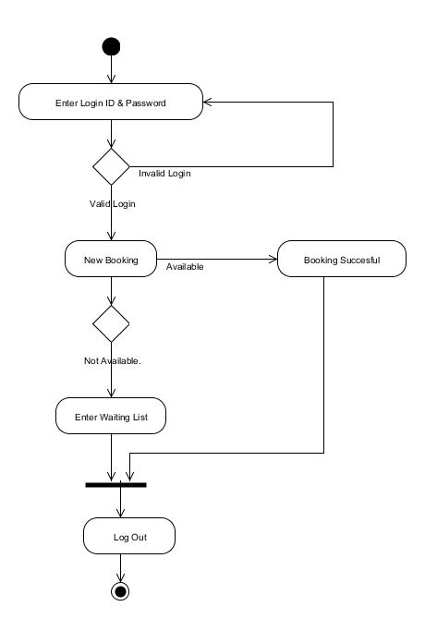

**A.4 UML USE CASE MODEL**

Figure A-2 shows the UML use case model.

Actor Name

The actor can be the administrator or any department.

**For User**

.Use Case Name: Book A Room

1. Theuser enters the credentials.

2. Check if it is right.

3. Selectthe room.

4. Check if it available.

5. Do the booking.

.Use Case Name: View Booking

1. Display the details of specific department booking details

.Use Case Name: Delete Booking

1. Delete According to the booking Id selected

.Use Case Name: Update Password

1. Enter the current password

2. Enter the new password.

3. Update the password.

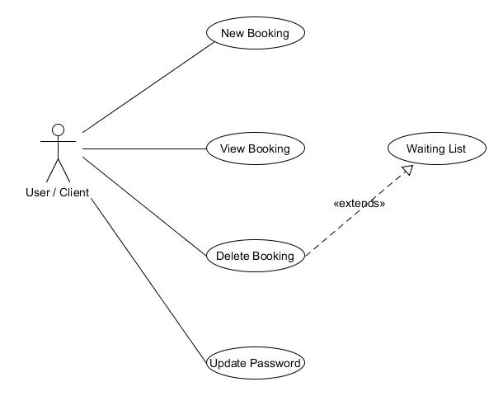

**For Administrator**

Use Case Name: Book a Room

1. Theuser enters the credentials.

2. Check if it is right.

3. Selectthe room.

4. Check if it available.

5. Do the booking.

.Use Case Name: View Booking

1. Display the details of specific department booking details

.Use Case Name: Delete Booking

1. Delete According to the booking Id selected

.Use Case Name: Update Password

1. Enter the current password

2. Enter the new password.

3. Update the password.

.Use Case Name: Update, Add, Delete Resources

1. Actions performed according to the admins specification.

.Use Case Name: Delete and Add Users

1. The admin has the right to add or delete the users.

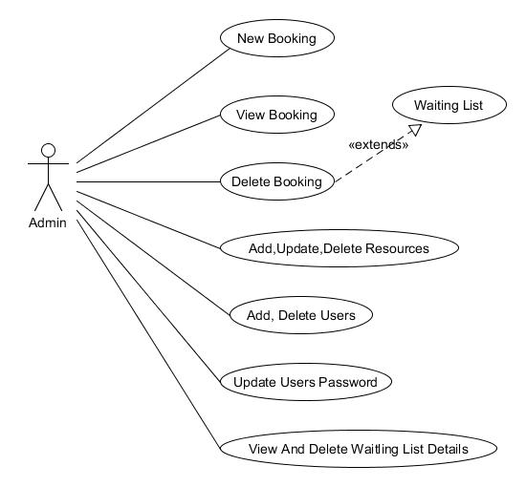

**A.5 UML INTERACTION DIAGRAM**

Figure A-5 shows the sequence and collaboration diagram for some of the preceding use cases.

**Sequence Diagram:**

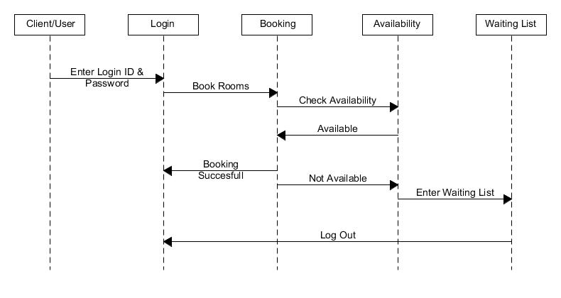

**Collaboration Diagram:**

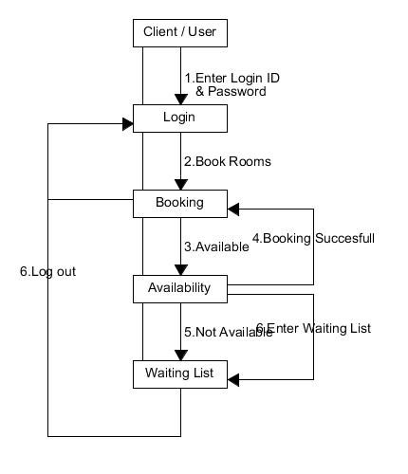

* 1. **DATA DICTIONARY**

Data Dictionary is a catalogue of all elements in a system. It is a document that collects co-ordinates and confirms what a specific data term mean to different people in the organization. It is the basic reference work for finding the names and attributes of data elements used throughout the system.

These elements center on data and the way they are structured to meet user requirements and organization needs. It is a must that all elements are included in the data dictionary. The major elements are data flows, data stored and process. Data dictionary stores details and descriptions of those elements. A well-developed data dictionary should be able to provide the following information.

* Number of characters are in a data item(data elements, fields)
* The name with which it is referenced
* The place where it is used

**BookingDetails:**

|  |  |  |
| --- | --- | --- |
| **Column Name** | **Data Type** | **Constraint** |
| LoginID | varchar(50) | Primary key |
| BookingID | int | Not Null |
| Venue | varchar(50) | Not Null |
| DepartmentName | varchar(50) | Not Null |
| Description | varchar(50) | Not Null |
| Date | datetime | Not Null |
| StartTime | varchar(50) | Not Null |
| EndTime | varchar(50) | Not Null |
| Chairs | Int | Not Null |
| mikes | int | Not Null |
| Projector | varchar(50) | Not Null |

**CancelDetails:**

|  |  |  |
| --- | --- | --- |
| **Column Name** | **Data Type** | **Constraint** |
| ListNo | Int | Primary Key |
| LoginId | varchar(50) | Not Null |
| BookingID | int | Not Null |
| Venue | varchar(50) | Not Null |
| Date | varchar(50) | Not Null |
| StartTime | varchar(50) | Not Null |
| EndTime | varchar(50) | Not Null |

**DeletedRooms**:

|  |  |  |
| --- | --- | --- |
| **Column Name** | **Data Type** | **Constraint** |
| SNo | Int | Primary Key |
| RoomName | Varchar(50) | Not Null |

**Department Names:**

|  |  |  |
| --- | --- | --- |
| **Column Name** | **Data Type** | **Constraint** |
| SNo | int | Primary Key |
| Department_Name | Varchar(50) | Not Null |

**LoginDetails:**

|  |  |  |
| --- | --- | --- |
| **Column Name** | **Data Type** | **Constraint** |
| LoginId | Int | Primary Key |
| Password | Varchar(50) | Not Null |
| DepartmentName | Varchar(50) | Not Null |

**NotifyDeletedRooms:**

|  |  |  |
| --- | --- | --- |
| **Column Name** | **Data Type** | **Constraint** |
| SNo | int | Primary Key |
| LoginID | varchar(50) | Not Null |
| BookingID | int | Not Null |
| venue | varchar(50) | Not Null |
| deptname | varchar(50) | Not Null |
| description | varchar(50) | Not Null |
| date | datetime | Not Null |

**ResourceDetails:**

|  |  |  |
| --- | --- | --- |
| **Column Name** | **Data Type** | **Constraint** |
| Venue | varchar(50) | Primary Key |
| Chairs | int | Not Null |
| Microphones | int | Not Null |
| Projector | varchar(50) | Not Null |
| Available | varchar(50) | Not Null |

**RoomPictures:**

|  |  |  |
| --- | --- | --- |
| **Column Name** | **Data Type** | **Constraint** |
| SNo | int | Primary Key |
| Room | varchar(50) | Not Null |
| RoomName | varchar(50) | Not Null |

**WaitingDetails:**

|  |  |  |
| --- | --- | --- |
| **Column Name** | **Data Type** | **Constraint** |
| waitingID | Int | Primary Key |
| priority | Int | Not Null |
| LoginID | varchar(50) | Not Null |
| BookingID | Int | Not Null |
| Venue | varchar(50) | Not Null |
| Date | datetime | Not Null |
| StartTime | varchar(50) | Not Null |
| EndTime | varchar(50) | Not Null |

**SCREEN DESIGN**

**SCREENSHOT**

**LoginPage:**

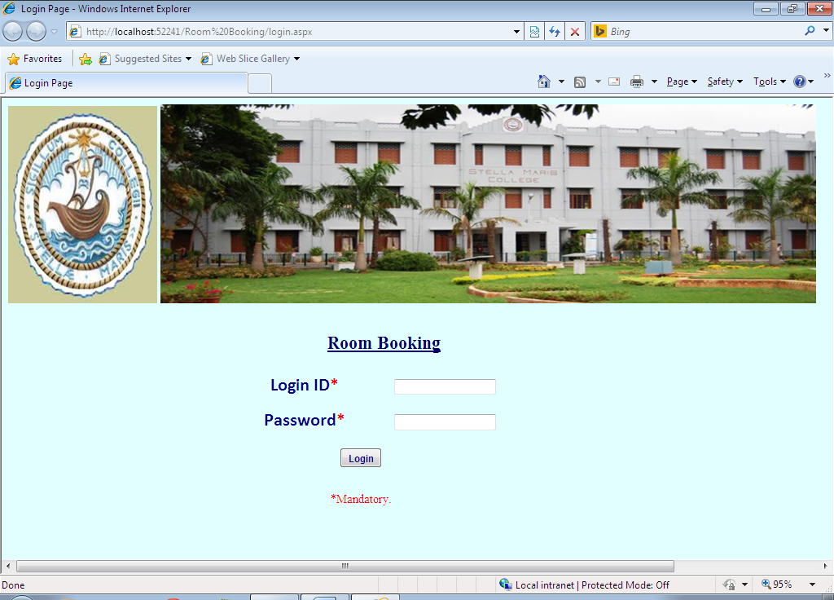

**AdminFrontPage:**

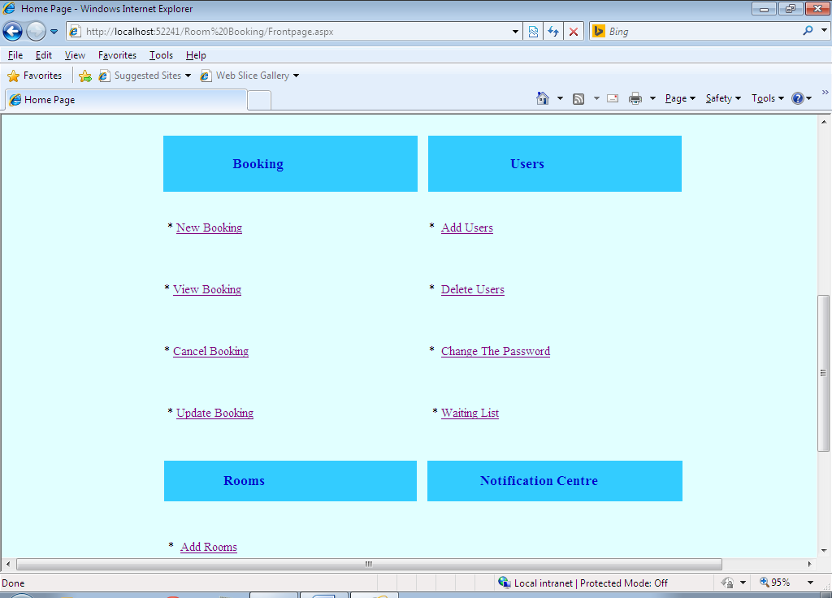

**Booking Page:**

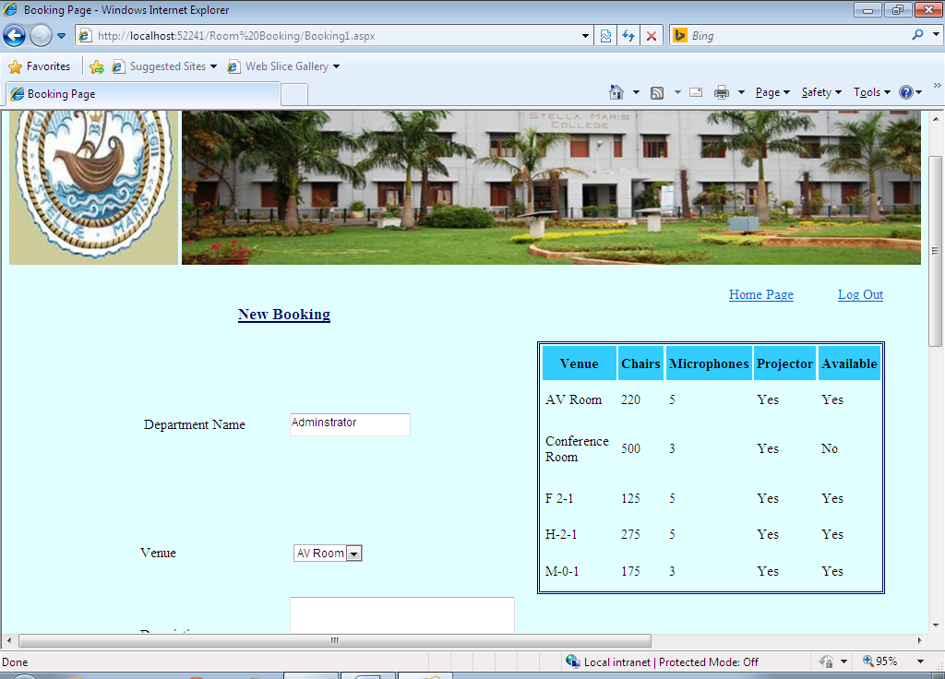

**View Booking:**

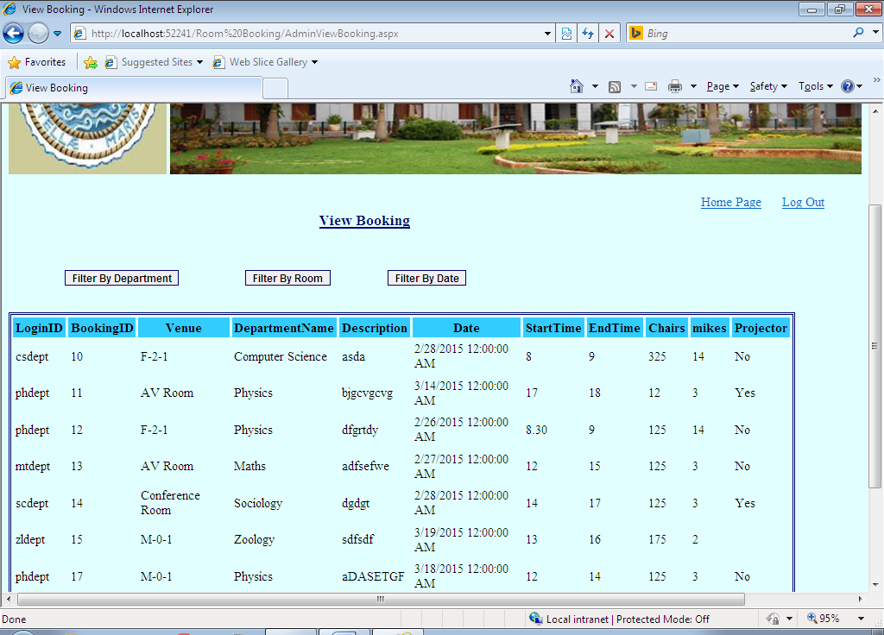

**Filter By Department:**

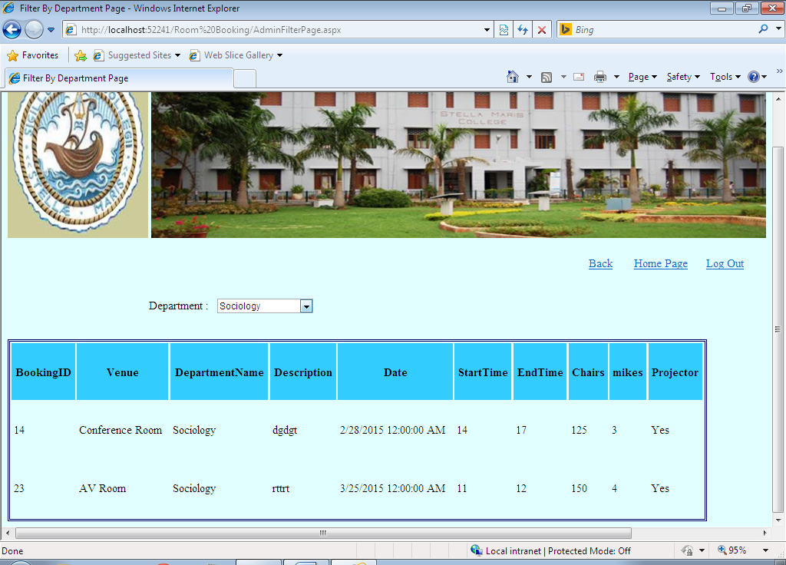

**Filter By Room:**

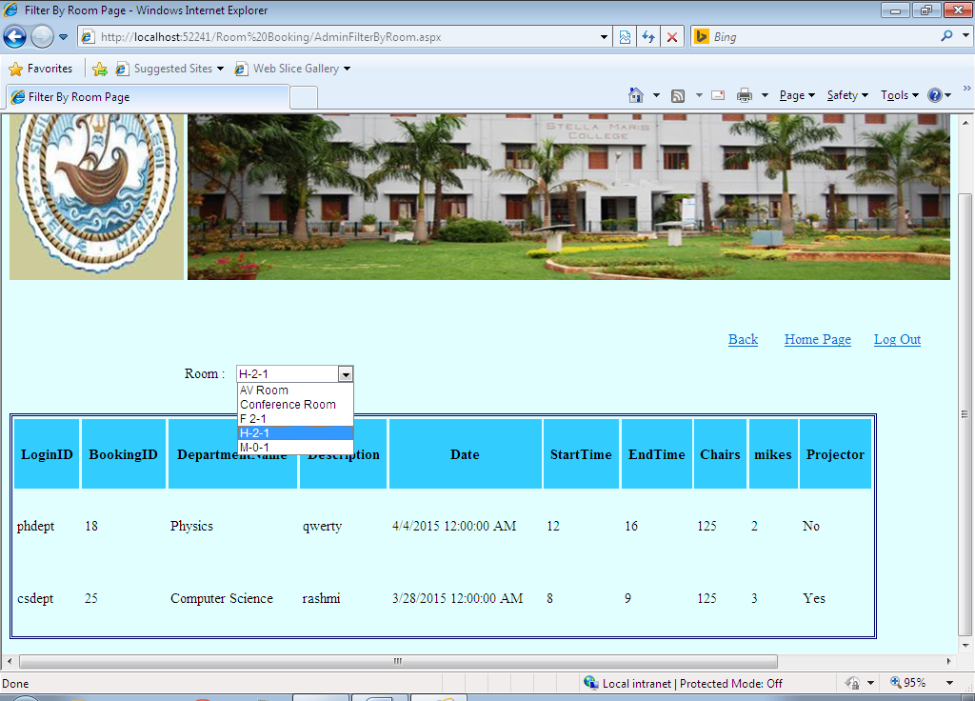

**Filter By Date**

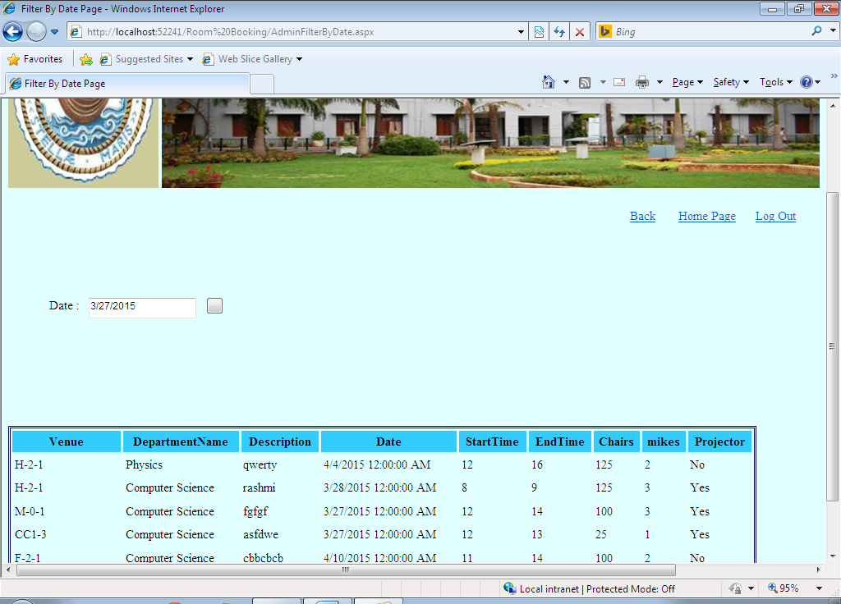

**Admin Delete Booking:**

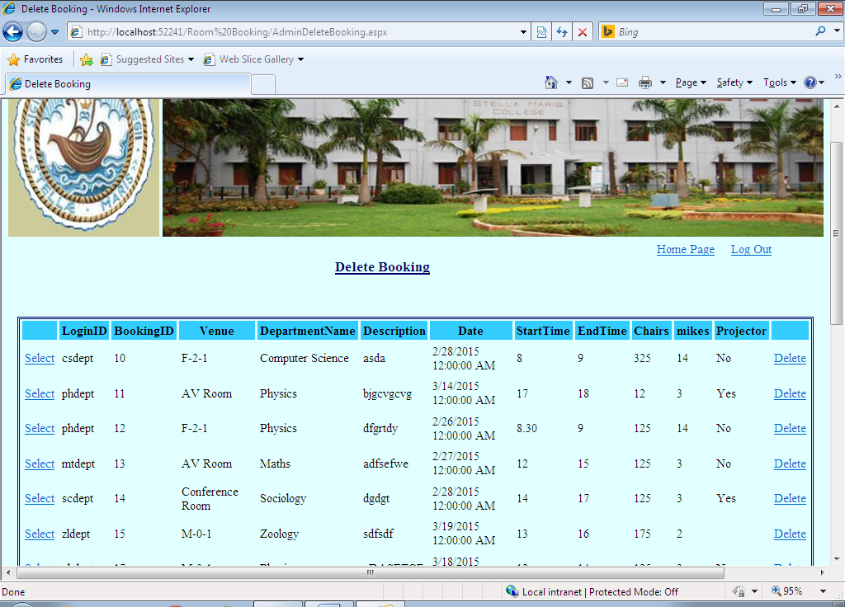

**Admin Update Booking:**

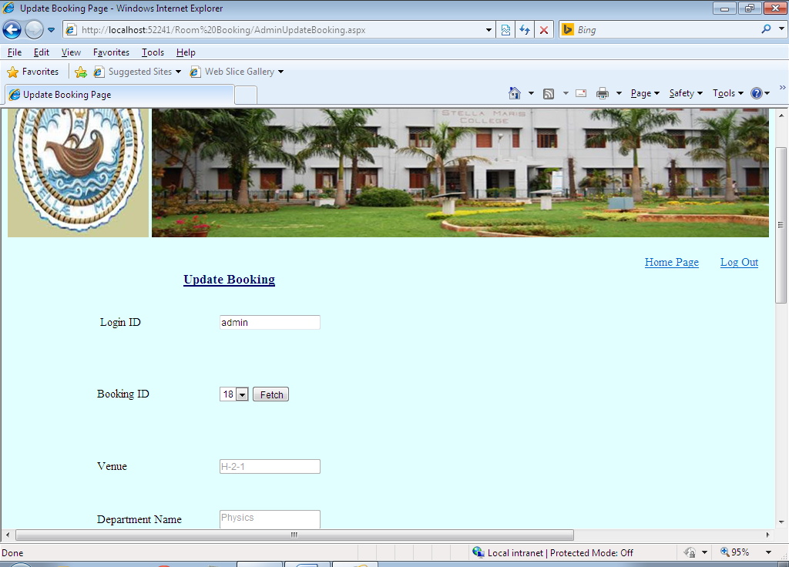

**Admin Add Users:**

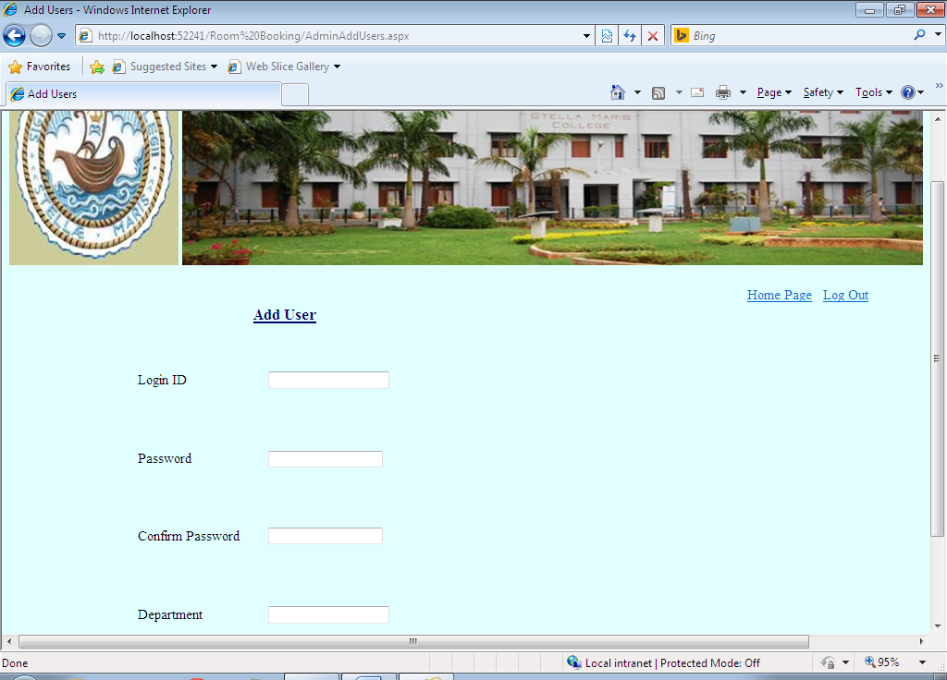

**Admin Delete Users:**

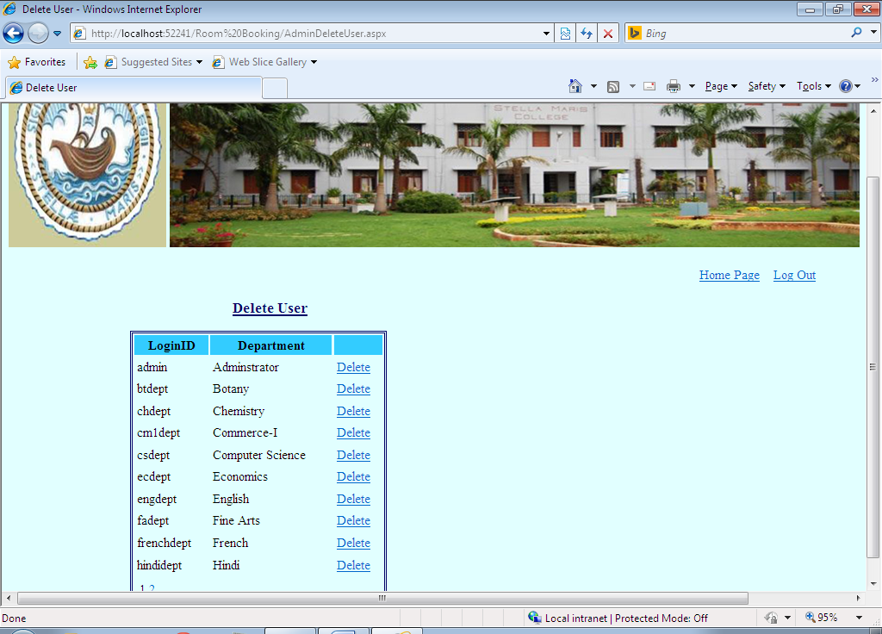

**Admin Change Password:**

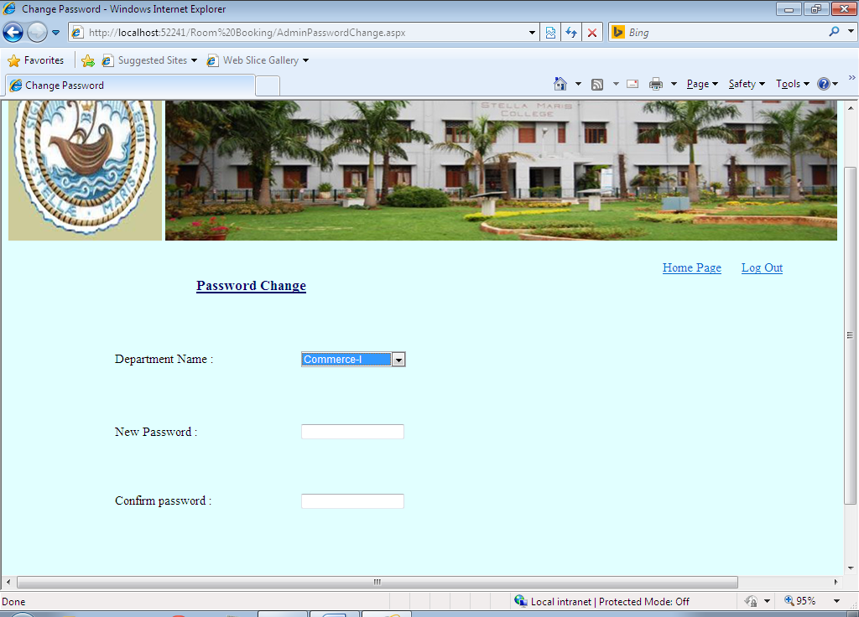

**Admin Waiting List:**

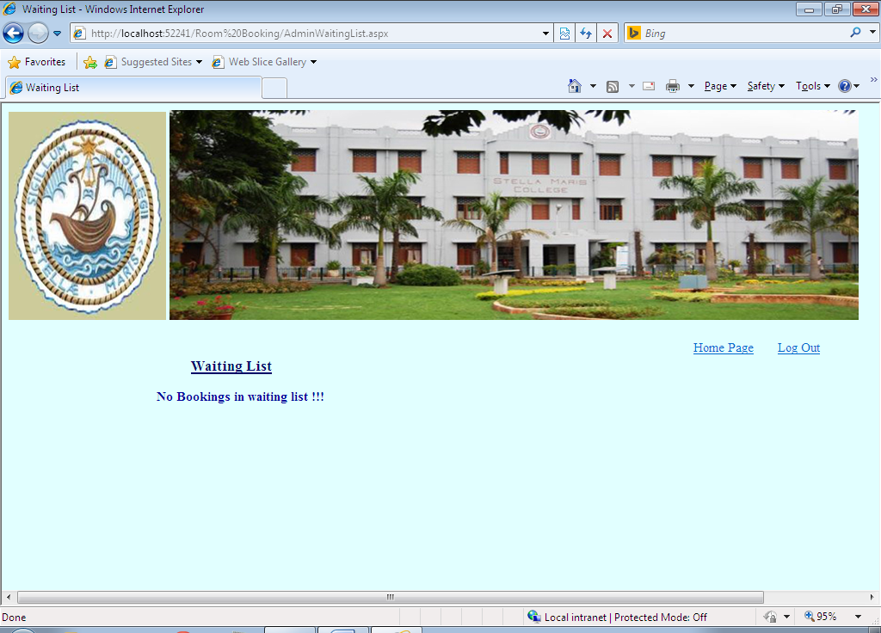

**Admin Add Room:**

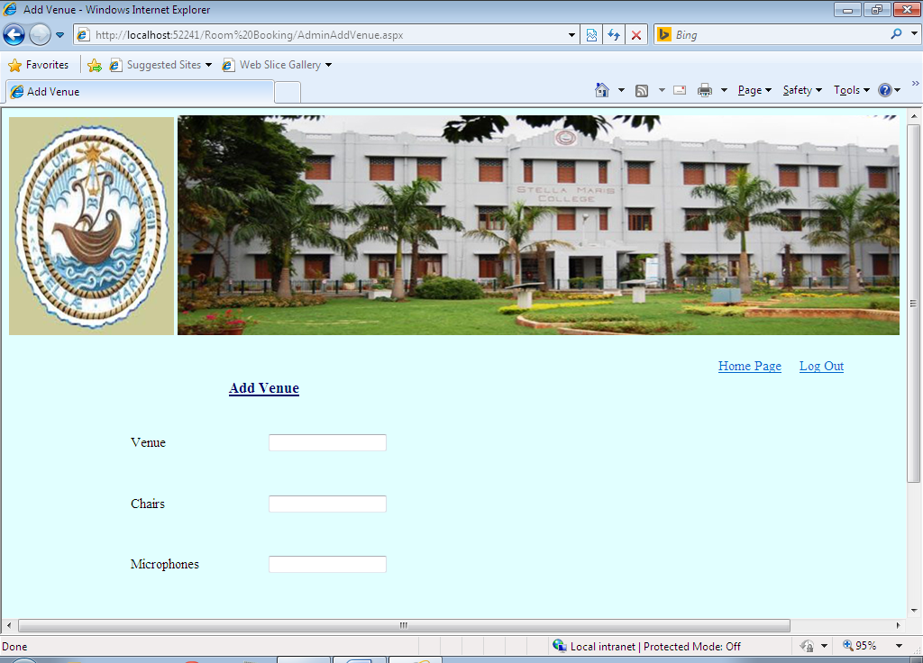

**Admin Delete Room:**

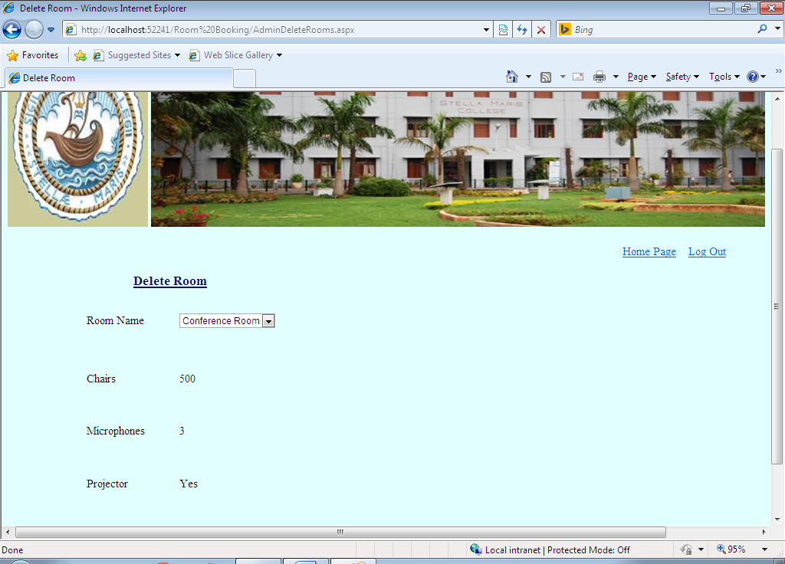

**Admin Update Venue:**

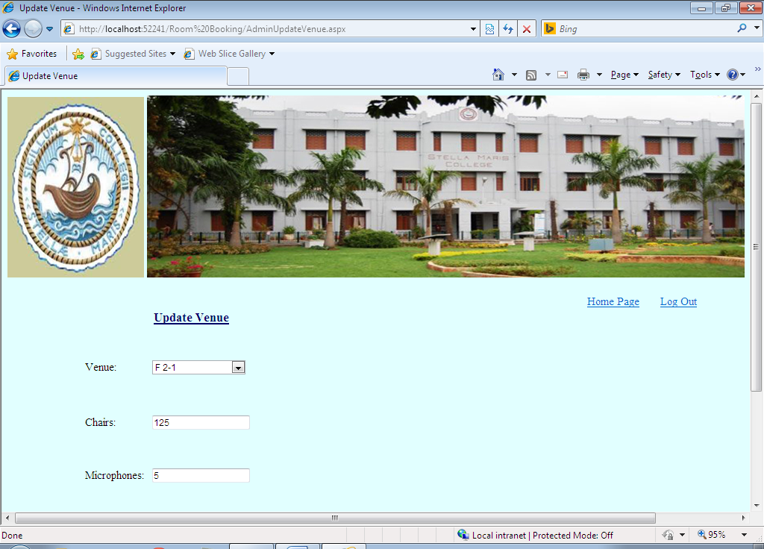

**Admin Upload Room Photos:**

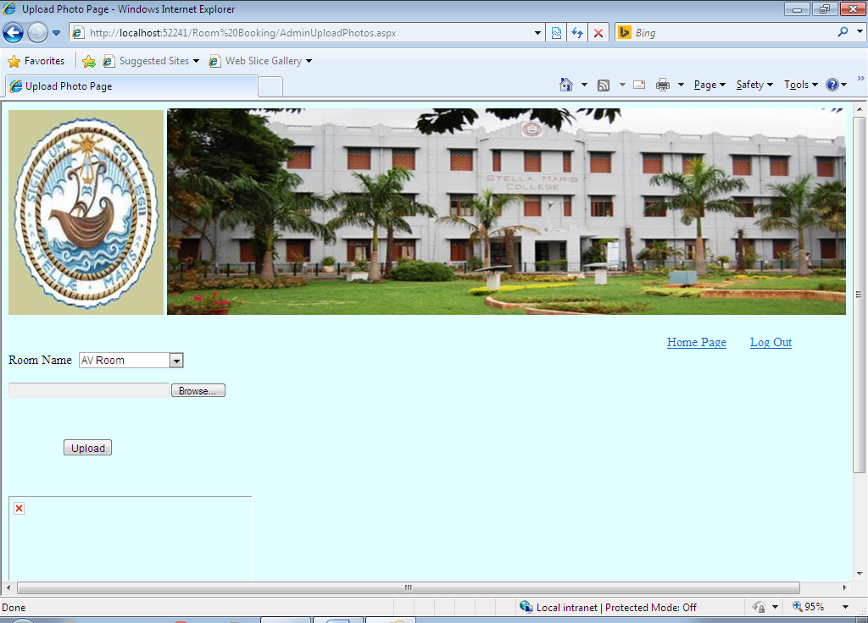

**Users Home Page:**

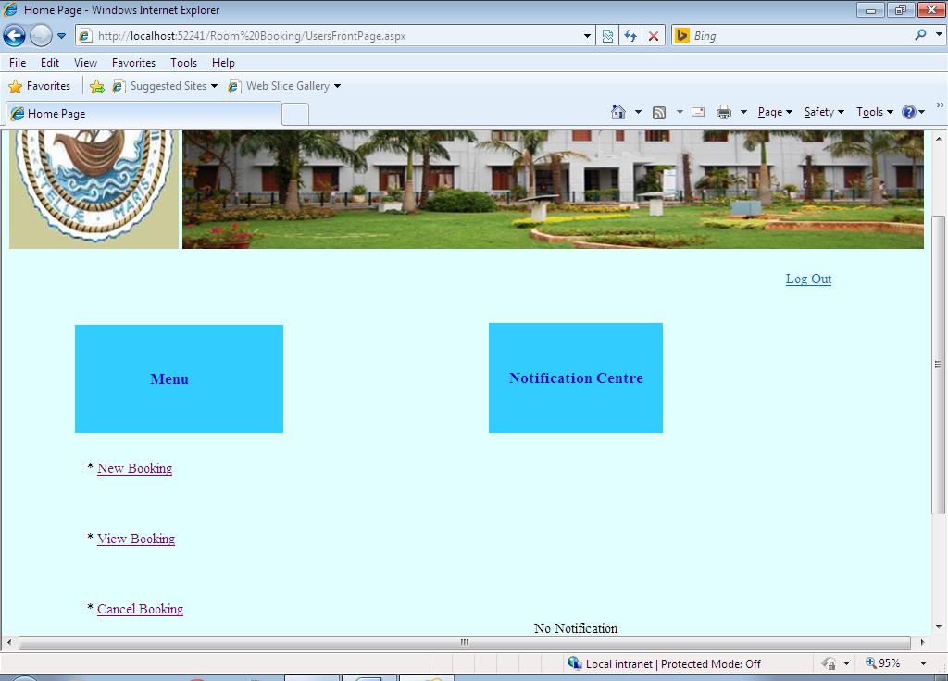

**Users View Booking:**

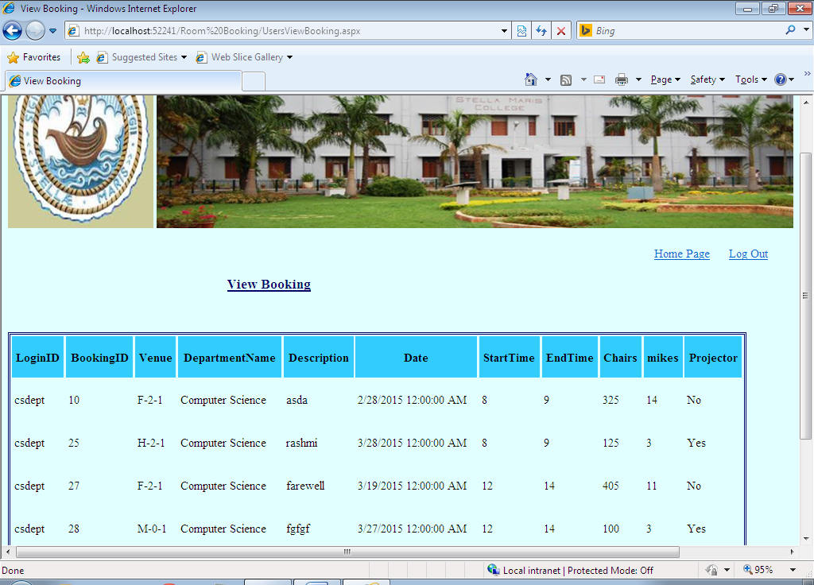

**User Delete Booking:**

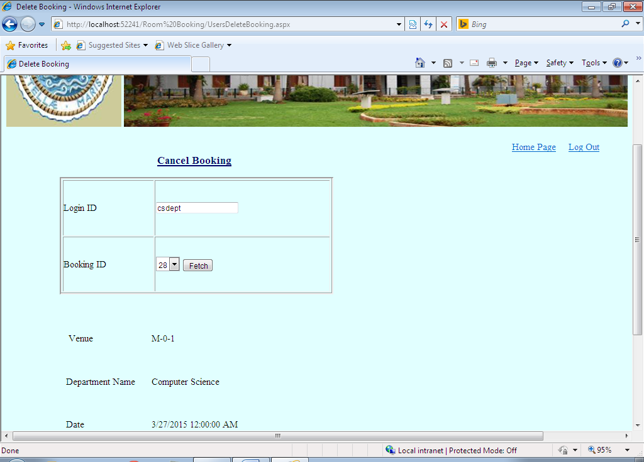

**User Change Password:**

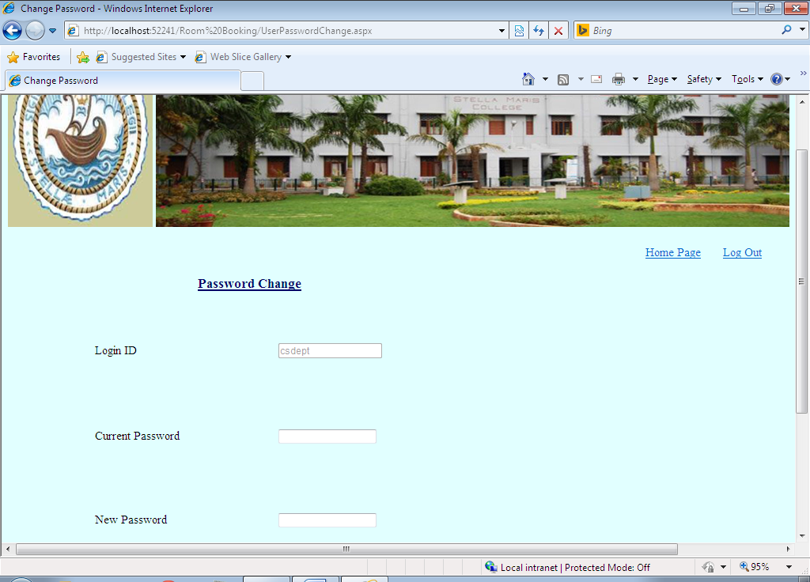

**CODING**

**CODING**

**AdminAddDepartment:**

Imports System.Data

Partial Class AdminAddDept

Inherits System.Web.UI.Page

Dim ad1 As OleDb.OleDbDataAdapter

Dim ds1 As New Data.DataSet

Dim cb1 As OleDb.OleDbCommandBuilder

Dim str1, conn As String

Protected Sub btnadd_Click(ByVal sender As Object, ByVal e As System.EventArgs) Handles btnadd.Click

Dim Rowno, Rownos, oldbkid, BkngID As Integer

conn="Provider=SQLOLEDB;Data Source=server2;database=12cs4027RoomBooking;uid=sa;pwd=stella"

str1 = "select * from DepartmentNames"

ad1 = New OleDb.OleDbDataAdapter(str1, conn)

ad1.Fill(ds1)

Rowno = ds1.Tables(0).Rows.Count

If Rowno = 0 Then

BkngID = 1

Else

Rownos = ds1.Tables(0).Rows.Count - 1

oldbkid = ds1.Tables(0).Rows(Rownos).Item(0)

BkngID = oldbkid + 1

End If

cb1 = New OleDb.OleDbCommandBuilder(ad1)

If Rowno = 0 Then

Dim items As Data.DataRow

items = ds1.Tables(0).NewRow

items(0) = BkngID

items(1) = tbxdeptname.Text

ds1.Tables(0).Rows.Add(items)

ad1.Update(ds1)

MsgBox("Added Successfully")

Response.Redirect("Frontpage.aspx")

Else

For i As Integer = 0 To ds1.Tables(0).Rows.Count - 1

If tbxdeptname.Text = ds1.Tables(0).Rows(i).Item(1) Then

MsgBox("This department already exists")

Exit For

Else

Dim items As Data.DataRow

items = ds1.Tables(0).NewRow

items(0) = BkngID

items(1) = tbxdeptname.Text

ds1.Tables(0).Rows.Add(items)

ad1.Update(ds1)

MsgBox("Added Successfully")

Response.Redirect("Frontpage.aspx")

End If

Next

End If

End Sub

End Class

**AdminAddUsers:**

Imports System.Data

Partial Class AdminAddDept

Inherits System.Web.UI.Page

Dim ad1 As OleDb.OleDbDataAdapter

Dim ds1 As New Data.DataSet

Dim cb1 As OleDb.OleDbCommandBuilder

Dim str1, conn As String

Protected Sub btnadd_Click(ByVal sender As Object, ByVal e As System.EventArgs) Handles btnadd.Click

Dim Rowno, Rownos, oldbkid, BkngID As Integer

conn="Provider=SQLOLEDB;Data Source=server2;database=12cs4027RoomBooking;uid=sa;pwd=stella"

str1 = "select * from DepartmentNames"

ad1 = New OleDb.OleDbDataAdapter(str1, conn)

ad1.Fill(ds1)

Rowno = ds1.Tables(0).Rows.Count

If Rowno = 0 Then

BkngID = 1

Else

Rownos = ds1.Tables(0).Rows.Count - 1

oldbkid = ds1.Tables(0).Rows(Rownos).Item(0)

BkngID = oldbkid + 1

End If

cb1 = New OleDb.OleDbCommandBuilder(ad1)

If Rowno = 0 Then

Dim items As Data.DataRow

items = ds1.Tables(0).NewRow

items(0) = BkngID

items(1) = tbxdeptname.Text

ds1.Tables(0).Rows.Add(items)

ad1.Update(ds1)

MsgBox("Added Successfully")

Response.Redirect("Frontpage.aspx")

Else

For i As Integer = 0 To ds1.Tables(0).Rows.Count - 1

If tbxdeptname.Text = ds1.Tables(0).Rows(i).Item(1) Then

MsgBox("This department already exists")

Exit For

Else

Dim items As Data.DataRow

items = ds1.Tables(0).NewRow

items(0) = BkngID

items(1) = tbxdeptname.Text

ds1.Tables(0).Rows.Add(items)

ad1.Update(ds1)

MsgBox("Added Successfully")

Response.Redirect("Frontpage.aspx")

End If

Next

End If

End Sub

End Class

**AdminAddVenue**

Imports System.Data

Partial Class AdminAddDept

Inherits System.Web.UI.Page

Dim ad1 As OleDb.OleDbDataAdapter

Dim ds1 As New Data.DataSet

Dim cb1 As OleDb.OleDbCommandBuilder

Dim str1, conn As String

Protected Sub btnadd_Click(ByVal sender As Object, ByVal e As System.EventArgs) Handles btnadd.Click

Dim Rowno, Rownos, oldbkid, BkngID As Integer

conn="Provider=SQLOLEDB;Data Source=server2;database=12cs4027RoomBooking;uid=sa;pwd=stella"

str1 = "select * from DepartmentNames"

ad1 = New OleDb.OleDbDataAdapter(str1, conn)

ad1.Fill(ds1)

Rowno = ds1.Tables(0).Rows.Count

If Rowno = 0 Then

BkngID = 1

Else

Rownos = ds1.Tables(0).Rows.Count - 1

oldbkid = ds1.Tables(0).Rows(Rownos).Item(0)

BkngID = oldbkid + 1

End If

cb1 = New OleDb.OleDbCommandBuilder(ad1)

If Rowno = 0 Then

Dim items As Data.DataRow

items = ds1.Tables(0).NewRow

items(0) = BkngID

items(1) = tbxdeptname.Text

ds1.Tables(0).Rows.Add(items)

ad1.Update(ds1)

MsgBox("Added Successfully")

Response.Redirect("Frontpage.aspx")

Else

For i As Integer = 0 To ds1.Tables(0).Rows.Count - 1

If tbxdeptname.Text = ds1.Tables(0).Rows(i).Item(1) Then

MsgBox("This department already exists")

Exit For

Else

Dim items As Data.DataRow

items = ds1.Tables(0).NewRow

items(0) = BkngID

items(1) = tbxdeptname.Text

ds1.Tables(0).Rows.Add(items)

ad1.Update(ds1)

MsgBox("Added Successfully")

Response.Redirect("Frontpage.aspx")

End If

Next

End If

End Sub

End Class

**AdminDeleteBooking**

Imports System.Data

Partial Class AdminChangePassword

Inherits System.Web.UI.Page

Dim ad, ad1, ad2, ad3 As OleDb.OleDbDataAdapter

Dim ds, ds1, ds2, ds3 As New Data.DataSet

Dim cb, cb1, cb2 As OleDb.OleDbCommandBuilder

Dim str, str1, str2, str3, conn As String

Dim SnLoginID As String

Protected Sub OnConfirm(ByVal sender As Object, ByVal e As EventArgs)

Dim i As Integer

Dim confirmValue As String = Request.Form("confirm_value")

Dim Rowno, BkngID, oldbkid, Rownos As Integer

If confirmValue = "Yes" Then

Dim row As GridViewRow = GridView1.SelectedRow

Dim flag As Integer

conn="Provider=SQLOLEDB;Data Source=server2;database=12cs4027RoomBooking;uid=sa;pwd=stella"

str1 = "select * from BookingDetails"

str2 = "select * from WaitingDetails"

str3 = "select * from CancelDetail"

ad1 = New OleDb.OleDbDataAdapter(str1, conn)

ad2 = New OleDb.OleDbDataAdapter(str2, conn)

ad3 = New OleDb.OleDbDataAdapter(str3, conn)

ad1.Fill(ds1)

ad2.Fill(ds2)

ad3.Fill(ds3)

cb = New OleDb.OleDbCommandBuilder(ad2)

cb1 = New OleDb.OleDbCommandBuilder(ad3)

cb2 = New OleDb.OleDbCommandBuilder(ad1)

Rowno = ds3.Tables(0).Rows.Count

If Rowno = 0 Then

BkngID = 1

Else

Rownos = ds3.Tables(0).Rows.Count - 1

oldbkid = ds3.Tables(0).Rows(Rownos).Item(0)

BkngID = oldbkid + 1

End If

For i = 0 To ds2.Tables(0).Rows.Count - 1

If row.Cells(2).Text = ds2.Tables(0).Rows(i).Item(3) Then

Dim items As Data.DataRow

items = ds3.Tables(0).NewRow

items(0) = BkngID

items(1) = ds2.Tables(0).Rows(i).Item(2)

items(2) = row.Cells(2).Text

items(3) = ds2.Tables(0).Rows(i).Item(4)

items(4) = ds2.Tables(0).Rows(i).Item(5)

items(5) = ds2.Tables(0).Rows(i).Item(6)

items(6) = ds2.Tables(0).Rows(i).Item(7)

ds3.Tables(0).Rows.Add(items)

MsgBox(ds2.Tables(0).Rows(i).Item(4))

ds2.Tables(0).Rows(i).Delete()

Exit For

Else

flag = 0

End If

Next

ad2.Update(ds2)

ad3.Update(ds3)

If flag = 0 Then

For i = 0 To ds1.Tables(0).Rows.Count - 1

If row.Cells(2).Text = ds1.Tables(0).Rows(i).Item(1) Then

ds1.Tables(0).Rows(i).Delete()

Exit For

End If

Next

ad1.Update(ds1)

End If

End If

Response.Redirect("AdminDeleteBooking.aspx")

End Sub

Protected Sub LinkButton1_Click(ByVal sender As Object, ByVal e As System.EventArgs) Handles LinkButton1.Click

Response.Cache.SetCacheability(HttpCacheability.NoCache)

Response.Cache.SetExpires(DateTime.UtcNow.AddHours(-1))

Response.Cache.SetNoStore()

Session.Clear()

End Sub

Protected Sub Page_Load(ByVal sender As Object, ByVal e As System.EventArgs) Handles Me.Load

conn="Provider=SQLOLEDB;Data Source=server2;database=12cs4027RoomBooking;uid=sa;pwd=stella"

str1 = "select * from BookingDetails"

ad1 = New OleDb.OleDbDataAdapter(str1, conn)

ad1.Fill(ds1)

cb1 = New OleDb.OleDbCommandBuilder(ad1)

If ds1.Tables(0).Rows.Count = 0 Then

Lblnotavail.Visible = True

GridView1.Visible = False

End If

End Sub

End Class

**AdminDeleteRooms**

Imports System.Data

Partial Class AdminChangePassword

Inherits System.Web.UI.Page

Dim ad, ad1, ad2, ad3 As OleDb.OleDbDataAdapter

Dim ds, ds1, ds2, ds3 As New Data.DataSet

Dim cb, cb1, cb2 As OleDb.OleDbCommandBuilder

Dim str, str1, str2, str3, conn As String

Dim SnLoginID As String

Protected Sub OnConfirm(ByVal sender As Object, ByVal e As EventArgs)

Dim i As Integer

Dim confirmValue As String = Request.Form("confirm_value")

Dim Rowno, BkngID, oldbkid, Rownos As Integer

If confirmValue = "Yes" Then

Dim row As GridViewRow = GridView1.SelectedRow

Dim flag As Integer

conn="Provider=SQLOLEDB;Data Source=server2;database=12cs4027RoomBooking;uid=sa;pwd=stella"

str1 = "select * from BookingDetails"

str2 = "select * from WaitingDetails"

str3 = "select * from CancelDetail"

ad1 = New OleDb.OleDbDataAdapter(str1, conn)

ad2 = New OleDb.OleDbDataAdapter(str2, conn)

ad3 = New OleDb.OleDbDataAdapter(str3, conn)

ad1.Fill(ds1)

ad2.Fill(ds2)

ad3.Fill(ds3)

cb = New OleDb.OleDbCommandBuilder(ad2)

cb1 = New OleDb.OleDbCommandBuilder(ad3)

cb2 = New OleDb.OleDbCommandBuilder(ad1)

Rowno = ds3.Tables(0).Rows.Count

If Rowno = 0 Then

BkngID = 1

Else

Rownos = ds3.Tables(0).Rows.Count - 1

oldbkid = ds3.Tables(0).Rows(Rownos).Item(0)

BkngID = oldbkid + 1

End If

For i = 0 To ds2.Tables(0).Rows.Count - 1

If row.Cells(2).Text = ds2.Tables(0).Rows(i).Item(3) Then

Dim items As Data.DataRow

items = ds3.Tables(0).NewRow

items(0) = BkngID

items(1) = ds2.Tables(0).Rows(i).Item(2)

items(2) = row.Cells(2).Text

items(3) = ds2.Tables(0).Rows(i).Item(4)

items(4) = ds2.Tables(0).Rows(i).Item(5)

items(5) = ds2.Tables(0).Rows(i).Item(6)

items(6) = ds2.Tables(0).Rows(i).Item(7)

ds3.Tables(0).Rows.Add(items)

MsgBox(ds2.Tables(0).Rows(i).Item(4))

ds2.Tables(0).Rows(i).Delete()

Exit For

Else

flag = 0

End If

Next

ad2.Update(ds2)

ad3.Update(ds3)

If flag = 0 Then

For i = 0 To ds1.Tables(0).Rows.Count - 1

If row.Cells(2).Text = ds1.Tables(0).Rows(i).Item(1) Then

ds1.Tables(0).Rows(i).Delete()

Exit For

End If

Next

ad1.Update(ds1)

End If

End If

Response.Redirect("AdminDeleteBooking.aspx")

End Sub

Protected Sub LinkButton1_Click(ByVal sender As Object, ByVal e As System.EventArgs) Handles LinkButton1.Click

Response.Cache.SetCacheability(HttpCacheability.NoCache)

Response.Cache.SetExpires(DateTime.UtcNow.AddHours(-1))

Response.Cache.SetNoStore()

Session.Clear()

End Sub

Protected Sub Page_Load(ByVal sender As Object, ByVal e As System.EventArgs) Handles Me.Load

conn="Provider=SQLOLEDB;Data Source=server2;database=12cs4027RoomBooking;uid=sa;pwd=stella"

str1 = "select * from BookingDetails"

ad1 = New OleDb.OleDbDataAdapter(str1, conn)

ad1.Fill(ds1)

cb1 = New OleDb.OleDbCommandBuilder(ad1)

If ds1.Tables(0).Rows.Count = 0 Then

Lblnotavail.Visible = True

GridView1.Visible = False

End If

End Sub

End Class

**AdminDeleteusers**

Partial Class AdminDeleteUser

Inherits System.Web.UI.Page

Protected Sub LinkButton1_Click(ByVal sender As Object, ByVal e As System.EventArgs) Handles LinkButton1.Click

Response.Cache.SetCacheability(HttpCacheability.NoCache)

Response.Cache.SetExpires(DateTime.UtcNow.AddHours(-1))

Response.Cache.SetNoStore()

Session.Clear()

End Sub

Protected Sub OnConfirm(ByVal sender As Object, ByVal e As EventArgs)

Dim confirmValue As String = Request.Form("confirm_value")

If confirmValue = "Yes" Then

MsgBox("Deleted successfully")

Else

Response.Redirect("AdminDeleteVenue.aspx")

End If

End Sub

End Class

**AdminFilterByDate**

Imports System.Data

Partial Class FilterByDate

Inherits System.Web.UI.Page

Private MinDate As Date = Date.MinValue

Private MaxDate As Date = Date.MaxValue

Dim ad1 As OleDb.OleDbDataAdapter

Dim ds1 As New Data.DataSet

Dim cb1 As OleDb.OleDbCommandBuilder

Dim str1, conn As String

Protected Sub btncal_Click(ByVal sender As Object, ByVal e As System.EventArgs) Handles btncal.Click

Caldate.Visible = True

End Sub

Protected Sub Caldate_DayRender(ByVal sender As Object, ByVal e As System.Web.UI.WebControls.DayRenderEventArgs) Handles Caldate.DayRender

If (e.Day.Date.DayOfWeek = DayOfWeek.Sunday) Then

e.Day.IsSelectable = False

End If

If e.Day.Date <= MinDate OrElse e.Day.Date >= MaxDate Then

e.Day.IsSelectable = False

End If

End Sub

Protected Sub Page_Load(ByVal sender As Object, ByVal e As System.EventArgs) Handles Me.Load

conn="Provider=SQLOLEDB;Data Source=server2;database=12cs4027RoomBooking;uid=sa;pwd=stella"

str1 = "select * from BookingDetails"

ad1 = New OleDb.OleDbDataAdapter(str1, conn)

ad1.Fill(ds1)

cb1 = New OleDb.OleDbCommandBuilder(ad1)

If ds1.Tables(0).Rows.Count = 0 Then

Lblnotavail.Visible = True

GridView1.Visible = False

End If

End Sub

Protected Sub Caldate_SelectionChanged(ByVal sender As Object, ByVal e As System.EventArgs) Handles Caldate.SelectionChanged

Textfromdate.Text = Caldate.SelectedDate

Caldate.Visible = False

conn="Provider=SQLOLEDB;Data Source=server2;database=12cs4027RoomBooking;uid=sa;pwd=stella"

str1 = "select * from BookingDetails"

ad1 = New OleDb.OleDbDataAdapter(str1, conn)

ad1.Fill(ds1)

cb1 = New OleDb.OleDbCommandBuilder(ad1)

If ds1.Tables(0).Rows.Count = 0 Then

Lblnotavail.Visible = True

GridView1.Visible = False

End If

Dim dateval As String = Textfromdate.Text

Try

For i As Integer = 0 To ds1.Tables(0).Rows.Count - 1

If dateval = ds1.Tables(0).Rows(i).Item(5) Then

GridView1.Visible = True

Lblnotavail.Visible = False

Exit For

Else

Lblnotavail.Visible = True

GridView1.Visible = False

End If

Next

Catch ex As Exception

End Try

End Sub

End Class

**AdminFilterByRoom**

Imports System.Data

Partial Class AdminFilterByRoom

Inherits System.Web.UI.Page

Dim ad1 As OleDb.OleDbDataAdapter

Dim ds1 As New Data.DataSet

Dim cb1 As OleDb.OleDbCommandBuilder

Dim str1, conn As String

Protected Sub Page_Load(ByVal sender As Object, ByVal e As System.EventArgs) Handles Me.Load

conn="Provider=SQLOLEDB;Data Source=server2;database=12cs4027RoomBooking;uid=sa;pwd=stella"

str1 = "select * from BookingDetails"

ad1 = New OleDb.OleDbDataAdapter(str1, conn)

ad1.Fill(ds1)

cb1 = New OleDb.OleDbCommandBuilder(ad1)

If ds1.Tables(0).Rows.Count = 0 Then

Lblnotavail.Visible = True

GridView1.Visible = False

End If

End Sub

Protected Sub DropDownList1_SelectedIndexChanged(ByVal sender As Object, ByVal e As System.EventArgs) Handles DropDownList1.SelectedIndexChanged

Dim venue As String = DropDownList1.SelectedItem.Text

Try

For i As Integer = 0 To ds1.Tables(0).Rows.Count - 1

If ds1.Tables(0).Rows(i).Item(2) = venue Then

GridView1.Visible = True

Lblnotavail.Visible = False

Exit For

Else

Lblnotavail.Visible = True

GridView1.Visible = False

End If

Next

Catch ex As Exception

End Try

If ds1.Tables(0).Rows.Count = 0 Then

Lblnotavail.Visible = True

GridView1.Visible = False

End If

End Sub

End Class

**AdminFilterByPage**

Imports System.Data

Partial Class AdminFilterPage

Inherits System.Web.UI.Page

Dim ad1 As OleDb.OleDbDataAdapter

Dim ds1 As New Data.DataSet

Dim cb1 As OleDb.OleDbCommandBuilder

Dim str1, conn As String

Protected Sub Page_Load(ByVal sender As Object, ByVal e As System.EventArgs) Handles Me.Load

conn="Provider=SQLOLEDB;Data Source=server2;database=12cs4027RoomBooking;uid=sa;pwd=stella"

str1 = "select * from BookingDetails"

ad1 = New OleDb.OleDbDataAdapter(str1, conn)

ad1.Fill(ds1)

cb1 = New OleDb.OleDbCommandBuilder(ad1)

If ds1.Tables(0).Rows.Count = 0 Then

Lblnotavail.Visible = True

GridView1.Visible = False

End If

End Sub

Protected Sub DropDownList1_SelectedIndexChanged(ByVal sender As Object, ByVal e As System.EventArgs) Handles DropDownList1.SelectedIndexChanged

Dim Dept As String = DropDownList1.SelectedItem.Text

Try

For i As Integer = 0 To ds1.Tables(0).Rows.Count - 1

If ds1.Tables(0).Rows(i).Item(3) = Dept Then

GridView1.Visible = True

Lblnotavail.Visible = False

Exit For

Else

Lblnotavail.Visible = True

GridView1.Visible = False

End If

Next

Catch ex As Exception

End Try

If ds1.Tables(0).Rows.Count = 0 Then

Lblnotavail.Visible = True

GridView1.Visible = False

End If

End Sub

End Class

**AdminPasswordChange**

Imports System.Data

Partial Class AdminFilterPage

Inherits System.Web.UI.Page

Dim ad1 As OleDb.OleDbDataAdapter

Dim ds1 As New Data.DataSet

Dim cb1 As OleDb.OleDbCommandBuilder

Dim str1, conn As String

Protected Sub Page_Load(ByVal sender As Object, ByVal e As System.EventArgs) Handles Me.Load

conn="Provider=SQLOLEDB;Data Source=server2;database=12cs4027RoomBooking;uid=sa;pwd=stella"

str1 = "select * from BookingDetails"

ad1 = New OleDb.OleDbDataAdapter(str1, conn)

ad1.Fill(ds1)

cb1 = New OleDb.OleDbCommandBuilder(ad1)

If ds1.Tables(0).Rows.Count = 0 Then

Lblnotavail.Visible = True

GridView1.Visible = False

End If

End Sub

Protected Sub DropDownList1_SelectedIndexChanged(ByVal sender As Object, ByVal e As System.EventArgs) Handles DropDownList1.SelectedIndexChanged

Dim Dept As String = DropDownList1.SelectedItem.Text

Try

For i As Integer = 0 To ds1.Tables(0).Rows.Count - 1

If ds1.Tables(0).Rows(i).Item(3) = Dept Then

GridView1.Visible = True

Lblnotavail.Visible = False

Exit For

Else

Lblnotavail.Visible = True

GridView1.Visible = False

End If

Next

Catch ex As Exception

End Try

If ds1.Tables(0).Rows.Count = 0 Then

Lblnotavail.Visible = True

GridView1.Visible = False

End If

End Sub

End Class

**AdminUpdateBooking**

Imports System.Data

Partial Class AdminUpdateBooking

Inherits System.Web.UI.Page

Dim ad As OleDb.OleDbDataAdapter

Dim ad1 As OleDb.OleDbDataAdapter

Dim ad2 As OleDb.OleDbDataAdapter

Dim ad3 As OleDb.OleDbDataAdapter

Dim ad4 As OleDb.OleDbDataAdapter

Dim ad5 As OleDb.OleDbDataAdapter

Dim ad6 As OleDb.OleDbDataAdapter

Dim ds As New Data.DataSet

Dim ds1 As New Data.DataSet

Dim ds2 As New Data.DataSet

Dim ds3 As New Data.DataSet

Dim ds4 As New Data.DataSet

Dim ds5 As New Data.DataSet

Dim ds6 As New Data.DataSet

Dim cb As OleDb.OleDbCommandBuilder

Dim str1, str2, str, conn, str3, str4, str5 As String

Dim SnLoginID As String

Dim BkngID, waitingID As Integer

Dim projec As String

Dim Rowno, Rowno1, Rowno2, Rownos, oldbkid, oldwtid, var As Integer

Protected Sub Page_Load(ByVal sender As Object, ByVal e As System.EventArgs) Handles Me.Load

SnLoginID = Session("LoginID").ToString

tbxloginid.Text = SnLoginID

tbxtodaydate.Text = Date.Today

End Sub

Protected Sub btnvalidate_Click(ByVal sender As Object, ByVal e As System.EventArgs) Handles btnvalidate.Click

If tbxmike.Text > textmike.Text Or tbxchair.Text > textchair.Text Then

MsgBox("Please enter a valid number")

btnvalidate.Visible = True

Else

Btnconfirm.Visible = True

btnvalidate.Visible = False

End If

If radiono.Checked = True Then

projec = "No"

ElseIf radioyes.Checked = True Then

projec = "Yes"

Else

MsgBox("please choose an option")

End If

End Sub

Protected Sub Btnconfirm_Click(ByVal sender As Object, ByVal e As System.EventArgs) Handles Btnconfirm.Click

If radiono.Checked = True Then

projec = "No"

ElseIf radioyes.Checked = True Then

projec = "Yes"

End If

conn="Provider=SQLOLEDB;Data Source=server2;database=12cs4027RoomBooking;uid=sa;pwd=stella"

str1 = "select * from BookingDetails"

ad1 = New OleDb.OleDbDataAdapter(str1, conn)

ad1.Fill(ds1)

cb = New OleDb.OleDbCommandBuilder(ad1)

For i As Integer = 0 To ds1.Tables(0).Rows.Count - 1

If dropdownbookingid.SelectedItem.Text = ds1.Tables(0).Rows(i).Item(1) Then

ds1.Tables(0).Rows(i).Item(4) = TbxDescription.Text

ds1.Tables(0).Rows(i).Item(8) = tbxchair.Text

ds1.Tables(0).Rows(i).Item(9) = tbxmike.Text

ds1.Tables(0).Rows(i).Item(10) = projec

End If

Next

ad1.Update(ds1)

MsgBox("Updation Successful")

Response.Redirect("Frontpage.aspx")

End Sub

Protected Sub Button1_Click(ByVal sender As Object, ByVal e As System.EventArgs) Handles Button1.Click

lblvenue.Visible = True

tbxvenue.Visible = True

tbxvenue.Enabled = False

lbldeptname.Visible = True

TbxDeptName.Visible = True

TbxDeptName.Enabled = False

lbldesc.Visible = True

TbxDescription.Visible = True

lbldate.Visible = True

TbxDate.Visible = True

TbxDate.Enabled = False

lblstarttime.Visible = True

TbxStrtTime.Visible = True

TbxStrtTime.Enabled = False

lblendtime.Visible = True

TbxEndTime.Visible = True

TbxEndTime.Enabled = False

Lblmikeavail.Visible = True

Lblmikemax.Visible = True

lblmike.Visible = True

tbxmike.Visible = True

LabelChair.Visible = True

Lblchairavail.Visible = True

tbxchair.Visible = True

Lblchairmax.Visible = True

LabelProjector.Visible = True

radiono.Visible = True

radioyes.Visible = True

btnvalidate.Visible = True

Dim bkid As Integer = dropdownbookingid.SelectedItem.Text

conn="Provider=SQLOLEDB;Data Source=server2;database=12cs4027RoomBooking;uid=sa;pwd=stella"

str = "select * from BookingDetails"

ad = New OleDb.OleDbDataAdapter(str, conn)

ad.Fill(ds)

For i As Integer = 0 To ds.Tables(0).Rows.Count - 1

If bkid = ds.Tables(0).Rows(i).Item(1) Then

tbxvenue.Text = ds.Tables(0).Rows(i).Item(2)

TbxDeptName.Text = ds.Tables(0).Rows(i).Item(3)

TbxDescription.Text = ds.Tables(0).Rows(i).Item(4)

TbxDate.Text = ds.Tables(0).Rows(i).Item(5)

TbxStrtTime.Text = ds.Tables(0).Rows(i).Item(6)

TbxEndTime.Text = ds.Tables(0).Rows(i).Item(7)

tbxmike.Text = ds.Tables(0).Rows(i).Item(9).ToString

tbxchair.Text = ds.Tables(0).Rows(i).Item(8).ToString

End If

Next

str2 = "select * from ResourceDetails"

ad3 = New OleDb.OleDbDataAdapter(str2, conn)

ad3.Fill(ds3)

For j As Integer = 0 To ds3.Tables(0).Rows.Count - 1

If tbxvenue.Text = ds3.Tables(0).Rows(j).Item(0) Then

textchair.Text = ds3.Tables(0).Rows(j).Item(1)

textmike.Text = ds3.Tables(0).Rows(j).Item(2)

textprojector.Text = ds3.Tables(0).Rows(j).Item(3)

Lblchairmax.Text = ds3.Tables(0).Rows(j).Item(1)

Lblmikemax.Text = ds3.Tables(0).Rows(j).Item(2)

End If

Next

End Sub

Protected Sub LinkButton1_Click(ByVal sender As Object, ByVal e As System.EventArgs) Handles LinkButton1.Click

Response.Cache.SetCacheability(HttpCacheability.NoCache)

Response.Cache.SetExpires(DateTime.UtcNow.AddHours(-1))

Response.Cache.SetNoStore()

Session.Clear()

End Sub

End Class

**AdminUpdateVenue**

Imports System.Data

Partial Class AdminUpdateVenue

Inherits System.Web.UI.Page

Dim ad As OleDb.OleDbDataAdapter

Dim ds As New Data.DataSet

Dim cb As OleDb.OleDbCommandBuilder

Dim str, conn As String

Protected Sub btnupdate_Click(ByVal sender As Object, ByVal e As System.EventArgs) Handles btnupdate.Click

Dim projector As String = ""

Dim available As String = ""

Dim flag = 0

If RadioButton2.Checked = True Then

projector = "No"

Label1.Visible = False

ElseIf RadioButton1.Checked = True Then

projector = "Yes"

Label1.Visible = False

Else

Label1.Visible = True

flag = 1

End If

If RadioButton4.Checked = True Then

available = "No"

Label2.Visible = False

ElseIf RadioButton3.Checked = True Then

available = "Yes"

Label2.Visible = False

Else

Label2.Visible = True

flag = 1

End If

If flag = 0 Then

conn="Provider=SQLOLEDB;Data Source=server2;database=12cs4027RoomBooking;uid=sa;pwd=stella"

str = "select * from ResourceDetails"

ad = New OleDb.OleDbDataAdapter(str, conn)

ad.Fill(ds)

cb = New OleDb.OleDbCommandBuilder(ad)

For i As Integer = 0 To ds.Tables(0).Rows.Count - 1

If DropDownList1.SelectedItem.Text = ds.Tables(0).Rows(i).Item(0) Then

ds.Tables(0).Rows(i).Item(1) = textchairs.Text

ds.Tables(0).Rows(i).Item(2) = textmic.Text

ds.Tables(0).Rows(i).Item(3) = projector

ds.Tables(0).Rows(i).Item(4) = available

End If

Next

ad.Update(ds)

MsgBox("Updated")

Response.Redirect("Frontpage.aspx")

Else

MsgBox("Please choose an option")

End If

End Sub

Protected Sub DropDownList1_SelectedIndexChanged(ByVal sender As Object, ByVal e As System.EventArgs) Handles DropDownList1.SelectedIndexChanged

conn="Provider=SQLOLEDB;Data Source=server2;database=12cs4027RoomBooking;uid=sa;pwd=stella"

str = "select * from ResourceDetails"

ad = New OleDb.OleDbDataAdapter(str, conn)

ad.Fill(ds)

cb = New OleDb.OleDbCommandBuilder(ad)

For i As Integer = 0 To ds.Tables(0).Rows.Count - 1

If DropDownList1.SelectedItem.Text = ds.Tables(0).Rows(i).Item(0) Then

textchairs.Text = ds.Tables(0).Rows(i).Item(1)

textmic.Text = ds.Tables(0).Rows(i).Item(2)

End If

Next

End Sub

Protected Sub LinkButton1_Click(ByVal sender As Object, ByVal e As System.EventArgs) Handles LinkButton1.Click

Response.Cache.SetCacheability(HttpCacheability.NoCache)

Response.Cache.SetExpires(DateTime.UtcNow.AddHours(-1))

Response.Cache.SetNoStore()

Session.Clear()

End Sub

End Class

**AdminUploadPhotos**

Imports System.Data

Partial Class AdminUploadPhotos

Inherits System.Web.UI.Page

Dim ad As OleDb.OleDbDataAdapter

Dim ds As New Data.DataSet

Dim cb As OleDb.OleDbCommandBuilder

Dim str, conn As String

Protected Sub Btnupload_Click(ByVal sender As Object, ByVal e As System.EventArgs) Handles Btnupload.Click

Dim SNo, SNos, oldSNo, NewSNo As Integer

Dim filePath = "Room/"

Dim filename = FileUpload1.FileName.ToString()

FileUpload1.SaveAs(Server.MapPath(filePath) + filename)

Image3.ImageUrl = filePath + filename

conn="Provider=SQLOLEDB;Data Source=server2;database=12cs4027RoomBooking;uid=sa;pwd=stella"

str = "select * from RoomPictures"

ad = New OleDb.OleDbDataAdapter(str, conn)

ad.Fill(ds)

cb = New OleDb.OleDbCommandBuilder(ad)

For i As Integer = 0 To ds.Tables(0).Rows.Count - 1

SNo = ds.Tables(0).Rows.Count

If SNo = 0 Then

NewSNo = 1

Else

SNos = ds.Tables(0).Rows.Count - 1

oldSNo = ds.Tables(0).Rows(SNos).Item(0)

NewSNo = oldSNo + 1

End If

Next

Dim items As Data.DataRow

items = ds.Tables(0).NewRow

items(0) = SNo

items(1) = Image3.ImageUrl.ToString

items(2) = DropDownList1.SelectedItem.Text

ds.Tables(0).Rows.Add(items)

ad.Update(ds)

MsgBox("Uploaded Successfully")

'Response.Redirect("Frontpage.aspx")

End Sub

End Class

**AdminViewBooking**

Imports System.Data

Partial Class AdminViewBooking

Inherits System.Web.UI.Page

Dim ad1 As OleDb.OleDbDataAdapter

Dim ds1 As New Data.DataSet

Dim cb1 As OleDb.OleDbCommandBuilder

Dim str1, conn As String

Protected Sub LinkButton1_Click(ByVal sender As Object, ByVal e As System.EventArgs) Handles LinkButton1.Click

Response.Cache.SetCacheability(HttpCacheability.NoCache)

Response.Cache.SetExpires(DateTime.UtcNow.AddHours(-1))

Response.Cache.SetNoStore()

Session.Clear()

End Sub

Protected Sub Page_Load(ByVal sender As Object, ByVal e As System.EventArgs) Handles Me.Load

conn="Provider=SQLOLEDB;Data Source=server2;database=12cs4027RoomBooking;uid=sa;pwd=stella"

str1 = "select * from BookingDetails"

ad1 = New OleDb.OleDbDataAdapter(str1, conn)

ad1.Fill(ds1)

cb1 = New OleDb.OleDbCommandBuilder(ad1)

If ds1.Tables(0).Rows.Count = 0 Then

Lblnotavail.Visible = True

GridView1.Visible = False

End If

End Sub

Protected Sub Btnfilter_Click(ByVal sender As Object, ByVal e As System.EventArgs) Handles Btnfilter.Click

Response.Redirect("AdminFilterPage.aspx")

End Sub

Protected Sub Btnfilteroom_Click(ByVal sender As Object, ByVal e As System.EventArgs) Handles Btnfilteroom.Click

Response.Redirect("AdminFilterByRoom.aspx")

End Sub

End Class

**AdminWaitingList**

Imports System.Data

Partial Class AdminWaitingList

Inherits System.Web.UI.Page

Dim ad1 As OleDb.OleDbDataAdapter

Dim ds1 As New Data.DataSet

Dim cb1 As OleDb.OleDbCommandBuilder

Dim str1, conn As String

Protected Sub LinkButton1_Click(ByVal sender As Object, ByVal e As System.EventArgs) Handles LinkButton1.Click

Response.Cache.SetCacheability(HttpCacheability.NoCache)

Response.Cache.SetExpires(DateTime.UtcNow.AddHours(-1))

Response.Cache.SetNoStore()

Session.Clear()

End Sub

Protected Sub Page_Load(ByVal sender As Object, ByVal e As System.EventArgs) Handles Me.Load

conn = "Provider=SQLOLEDB;Data Source=server2;database=12cs4027RoomBooking;uid=sa;pwd=stella"

str1 = "select * from WaitingDetails"

ad1 = New OleDb.OleDbDataAdapter(str1, conn)

ad1.Fill(ds1)

cb1 = New OleDb.OleDbCommandBuilder(ad1)

If ds1.Tables(0).Rows.Count = 0 Then

Lblnotavail.Visible = True

GridView1.Visible = False

End If

End Sub

End Class

**BookingPage**

Imports System.Data

Partial Class Booking

Inherits System.Web.UI.Page

Dim ad As OleDb.OleDbDataAdapter

Dim ad1 As OleDb.OleDbDataAdapter

Dim ad2 As OleDb.OleDbDataAdapter

Dim ad3 As OleDb.OleDbDataAdapter

Dim ad4 As OleDb.OleDbDataAdapter

Dim ad5 As OleDb.OleDbDataAdapter

Dim ds As New Data.DataSet

Dim ds1 As New Data.DataSet

Dim ds2 As New Data.DataSet

Dim ds3 As New Data.DataSet

Dim ds4 As New Data.DataSet

Dim ds5 As New Data.DataSet

Dim cb As OleDb.OleDbCommandBuilder

Dim str1, str2, str, conn, str3, str4 As String

Dim SnLoginID As String

Dim BkngID, waitingID As Integer

Dim projector As String = ""

Dim Rowno, Rowno1, Rowno2, Rownos, oldbkid, oldwtid, BookingID As Integer

Private MinDate As Date = Date.MinValue

Private MaxDate As Date = Date.MaxValue

Protected Sub btncal_Click(ByVal sender As Object, ByVal e As System.EventArgs) Handles btncal.Click

Caldate.Visible = True

End Sub

Protected Sub Caldate_SelectionChanged(ByVal sender As Object, ByVal e As System.EventArgs) Handles Caldate.SelectionChanged

TbxDate.Text = Caldate.SelectedDate

If TbxDate.Text >= RangeValidatordate.MinimumValue Or TbxDate.Text <= RangeValidatordate.MaximumValue Then

Caldate.Visible = False

Label1.Visible = False

Else

Label1.Visible = True

TbxDate.Text = ""

TbxDate.Focus()

End If

End Sub

Protected Sub Caldate_DayRender(ByVal sender As Object, ByVal e As System.Web.UI.WebControls.DayRenderEventArgs) Handles Caldate.DayRender

If (e.Day.Date.DayOfWeek = DayOfWeek.Sunday) Then

e.Day.IsSelectable = False

End If

If e.Day.Date <= MinDate OrElse e.Day.Date >= MaxDate Then

e.Day.IsSelectable = False

End If

End Sub

Protected Sub Page_Load(ByVal sender As Object, ByVal e As System.EventArgs) Handles Me.Load

RangeValidatordate.MinimumValue = DateTime.Now.Date.ToString("MM/dd/yy")

RangeValidatordate.MaximumValue = Date.Today.AddMonths(1)

MinDate = Date.Today

MaxDate = MinDate.AddMonths(1)

conn="Provider=SQLOLEDB;Data Source=server2;database=12cs4027RoomBooking;uid=sa;pwd=stella"

str = "select * from LoginDetails"

ad = New OleDb.OleDbDataAdapter(str, conn)

ad.Fill(ds)

SnLoginID = Session("LoginID").ToString

tbxloginid.Text = SnLoginID

For i As Integer = 0 To ds.Tables(0).Rows.Count - 1

If tbxloginid.Text = ds.Tables(0).Rows(i).Item(0) Then

TbxDeptName.Text = ds.Tables(0).Rows(i).Item(2).ToString

End If

Next

str1 = "select * from BookingDetails"

ad1 = New OleDb.OleDbDataAdapter(str1, conn)

ad1.Fill(ds1)

Rowno = ds1.Tables(0).Rows.Count

If Rowno = 0 Then

BkngID = 1

Else

Rownos = ds1.Tables(0).Rows.Count - 1

oldbkid = ds1.Tables(0).Rows(Rownos).Item(1)

BkngID = oldbkid + 1

End If

TbxBkId.Text = BkngID

End Sub

Protected Sub Btnchkavil_Click(ByVal sender As Object, ByVal e As System.EventArgs) Handles Btnchkavil.Click

conn = "Provider=SQLOLEDB;Data Source=server2;database=12cs4027RoomBooking;uid=sa;pwd=stella"

str1 = "select * from BookingDetails"

ad2 = New OleDb.OleDbDataAdapter(str1, conn)

ad2.Fill(ds2)

Dim Venue As String = Drpvenue.SelectedItem.Text

Dim BookingDate As Date = TbxDate.Text

Dim StrtTime As Double = TbxStrtTime.Text

Dim EdTime As Double = TbxEndTime.Text

Dim i As Integer

If EdTime < StrtTime Then

MsgBox("End Time Should be greater than start time")

TbxEndTime.Text = ""

TbxEndTime.Focus()

LabelAvailable.Visible = False

LabelMike.Visible = False

tbxmike.Visible = False

LabelChair.Visible = False

tbxchair.Visible = False

LabelProjector.Visible = False

radioyes.Visible = False

radiono.Visible = False

Drpvenue.Enabled = True

btncal.Visible = True

TbxEndTime.Enabled = True

TbxStrtTime.Enabled = True

Btnchkavil.Visible = True

TbxBkId.Enabled = True

TbxDeptName.Enabled = True

TbxDescription.Enabled = True

tbxloginid.Enabled = True

LabelAvailable.Visible = False

LabelMike.Visible = False

tbxmike.Visible = False

LabelChair.Visible = False

tbxchair.Visible = False

LabelProjector.Visible = False

radioyes.Visible = False

radiono.Visible = False

Btnconfirm.Visible = False

Lblmikeavail.Visible = False

Lblchairavail.Visible = False

Lblmikemax.Visible = False

Lblchairmax.Visible = False

ElseIf ds2.Tables(0).Rows.Count = 0 Then

LabelAvailable.Visible = True

LabelMike.Visible = True

tbxmike.Visible = True

LabelChair.Visible = True

tbxchair.Visible = True

LabelProjector.Visible = True

radioyes.Visible = True

radiono.Visible = True

Drpvenue.Enabled = False

btncal.Visible = False

TbxEndTime.Enabled = False

TbxStrtTime.Enabled = False

Btnchkavil.Visible = False

TbxBkId.Enabled = False

TbxDeptName.Enabled = False

TbxDescription.Enabled = False

tbxloginid.Enabled = False

LabelAvailable.Visible = True

LabelMike.Visible = True

tbxmike.Visible = True

LabelChair.Visible = True

tbxchair.Visible = True

LabelProjector.Visible = True

radioyes.Visible = True

radiono.Visible = True

Btnconfirm.Visible = True

str2 = "select * from ResourceDetails"

ad3 = New OleDb.OleDbDataAdapter(str2, conn)

ad3.Fill(ds3)

For j As Integer = 0 To ds3.Tables(0).Rows.Count - 1

If Venue = ds3.Tables(0).Rows(j).Item(0) Then

textchair.Text = ds3.Tables(0).Rows(j).Item(1)

textmike.Text = ds3.Tables(0).Rows(j).Item(2)

textprojector.Text = ds3.Tables(0).Rows(j).Item(3)

Lblchairmax.Text = ds3.Tables(0).Rows(j).Item(1)

Lblmikemax.Text = ds3.Tables(0).Rows(j).Item(2)

End If

Next

Lblmikeavail.Visible = True

Lblchairavail.Visible = True

Lblmikemax.Visible = True

Lblchairmax.Visible = True

Else

If ds2.Tables(0).Rows.Count > 0 Then

For i = 0 To ds2.Tables(0).Rows.Count - 1

If TbxDeptName.Text = ds2.Tables(0).Rows(i).Item(3) And Venue = ds2.Tables(0).Rows(i).Item(2) And BookingDate = ds2.Tables(0).Rows(i).Item(5) And StrtTime <= ds2.Tables(0).Rows(i).Item(7) And EdTime <= ds2.Tables(0).Rows(i).Item(7) Then

MsgBox("Already booked by the same department")

If TbxDeptName.Text = "Adminstrator" Then

Response.Redirect("Frontpage.aspx")

Else

Response.Redirect("UsersFrontPage.aspx")

End If

ElseIf Venue = ds2.Tables(0).Rows(i).Item(2) And BookingDate = ds2.Tables(0).Rows(i).Item(5) And (StrtTime <= ds2.Tables(0).Rows(i).Item(7) Or EdTime <= ds2.Tables(0).Rows(i).Item(7)) Then

Btnchkavil.Visible = False

LabelNotAvailable.Visible = True

Btnwaitinglist.Visible = True

LabelAvailable.Visible = False

LabelMike.Visible = False

tbxmike.Visible = False

LabelChair.Visible = False

tbxchair.Visible = False

LabelProjector.Visible = False

radioyes.Visible = False

radiono.Visible = False

Btnconfirm.Visible = False

Lblmikeavail.Visible = False

Lblchairavail.Visible = False

Lblmikemax.Visible = False

Lblchairmax.Visible = False

Exit For

Else

Drpvenue.Enabled = False

btncal.Visible = False

TbxEndTime.Enabled = False

TbxStrtTime.Enabled = False

Btnchkavil.Visible = False

TbxBkId.Enabled = False

TbxDeptName.Enabled = False

TbxDescription.Enabled = False

tbxloginid.Enabled = False

LabelAvailable.Visible = True

LabelMike.Visible = True

tbxmike.Visible = True

LabelChair.Visible = True

tbxchair.Visible = True

LabelProjector.Visible = True

radioyes.Visible = True

radiono.Visible = True

Btnconfirm.Visible = True

str2 = "select * from ResourceDetails"

ad3 = New OleDb.OleDbDataAdapter(str2, conn)

ad3.Fill(ds3)

For j As Integer = 0 To ds3.Tables(0).Rows.Count - 1

If Venue = ds3.Tables(0).Rows(j).Item(0) Then

textchair.Text = ds3.Tables(0).Rows(j).Item(1)

textmike.Text = ds3.Tables(0).Rows(j).Item(2)

textprojector.Text = ds3.Tables(0).Rows(j).Item(3)

Lblchairmax.Text = ds3.Tables(0).Rows(j).Item(1)

Lblmikemax.Text = ds3.Tables(0).Rows(j).Item(2)

End If

Next

Lblmikeavail.Visible = True

Lblchairavail.Visible = True

Lblmikemax.Visible = True

Lblchairmax.Visible = True

End If

Next

End If

End If

End Sub

Protected Sub BtnBook_Click(ByVal sender As Object, ByVal e As System.EventArgs) Handles BtnBook.Click

If radiono.Checked = True Then

projector = "No"

ElseIf radioyes.Checked = True Then

projector = "Yes"

Else

MsgBox("please choose an option")

End If

End Sub

Protected Sub Btnconfirm_Click(ByVal sender As Object, ByVal e As System.EventArgs) Handles Btnconfirm.Click

If tbxmike.Text <= textmike.Text And tbxchair.Text <= textchair.Text Then

BtnBook.Visible = True

Btnconfirm.Visible = False

Else

Btnconfirm.Visible = True

tbxmike.Enabled = True

tbxmike.Enabled = True

End If

If radiono.Checked = True Then

projector = "No"

ElseIf radioyes.Checked = True Then

projector = "Yes"

Else

MsgBox("please choose an option")

Btnconfirm.Visible = True

BtnBook.Visible = False

End If

End Sub

Protected Sub OnConfirm(ByVal sender As Object, ByVal e As EventArgs) Handles BtnBook.Click

If radiono.Checked = True Then

projector = "No"

ElseIf radioyes.Checked = True Then

projector = "Yes"

End If

Dim confirmValue As String = Request.Form("confirm_value")

If confirmValue = "Yes" Then

conn="Provider=SQLOLEDB;Data Source=server2;database=12cs4027RoomBooking;uid=sa;pwd=stella"

str1 = "select * from BookingDetails"

ad1 = New OleDb.OleDbDataAdapter(str1, conn)

ad1.Fill(ds1)

cb = New OleDb.OleDbCommandBuilder(ad1)

Dim items As Data.DataRow

items = ds1.Tables(0).NewRow

items(0) = tbxloginid.Text

items(1) = TbxBkId.Text

items(2) = Drpvenue.SelectedItem.Text

items(3) = TbxDeptName.Text

items(4) = TbxDescription.Text

items(5) = TbxDate.Text

items(6) = TbxStrtTime.Text

items(7) = TbxEndTime.Text

items(8) = tbxchair.Text

items(9) = tbxmike.Text

items(10) = projector

ds1.Tables(0).Rows.Add(items)

ad1.Update(ds1)

MsgBox("Booking Successful")

If TbxDeptName.Text = "Adminstrator" Then

Response.Redirect("Frontpage.aspx")

Else

Response.Redirect("UsersFrontPage.aspx")

End If

Else

Response.Redirect("Booking1.aspx")

End If

End Sub

Protected Sub Onwaiting(ByVal sender As Object, ByVal e As EventArgs) Handles Btnwaitinglist.Click

Dim confirmValue As String = Request.Form("confirm_value")

If confirmValue = "Yes" Then

conn="Provider=SQLOLEDB;Data Source=server2;database=12cs4027RoomBooking;uid=sa;pwd=stella"

str4 = "select * from BookingDetails"

ad5 = New OleDb.OleDbDataAdapter(str4, conn)

ad5.Fill(ds5)

Dim Venue As String = Drpvenue.SelectedItem.Text

Dim BookingDate As Date = TbxDate.Text

Dim StrtTime As Double = TbxStrtTime.Text

Dim EdTime As Double = TbxEndTime.Text

Dim flag = 0

For i = 0 To ds5.Tables(0).Rows.Count - 1

'MsgBox("Hey")

If ((Venue = ds5.Tables(0).Rows(i).Item(2)) And (BookingDate = ds5.Tables(0).Rows(i).Item(5)) And ((StrtTime <= ds5.Tables(0).Rows(i).Item(7)) Or (EdTime <= ds5.Tables(0).Rows(i).Item(7)))) Then

BookingID = ds5.Tables(0).Rows(i).Item(1)

End If

Next

str3 = "select * from WaitingDetails"

ad4 = New OleDb.OleDbDataAdapter(str3, conn)

ad4.Fill(ds4)

cb = New OleDb.OleDbCommandBuilder(ad4)

Rowno1 = ds4.Tables(0).Rows.Count

If Rowno1 = 0 Then

waitingID = 1

Else

Rowno2 = ds4.Tables(0).Rows.Count - 1

oldwtid = ds4.Tables(0).Rows(Rowno2).Item(0)

waitingID = oldwtid + 1

End If

If ds4.Tables(0).Rows.Count = 0 Then

Dim items As Data.DataRow

items = ds4.Tables(0).NewRow

items(0) = waitingID

items(1) = 1

items(2) = SnLoginID

items(3) = BookingID

items(4) = Venue

items(5) = BookingDate

items(6) = StrtTime

items(7) = EdTime

ds4.Tables(0).Rows.Add(items)

ad4.Update(ds4)

MsgBox("Succesfully entered into the waiting list")

If TbxDeptName.Text = "Adminstrator" Then

Response.Redirect("Frontpage.aspx")

Else

Response.Redirect("UsersFrontPage.aspx")

End If

Else

If ds4.Tables(0).Rows.Count > 0 Then

For j As Integer = 0 To ds4.Tables(0).Rows.Count - 1

If BookingID = ds4.Tables(0).Rows(j).Item(3) Then

flag = 0

MsgBox("Sorry,The waiting list is full")

If TbxDeptName.Text = "Adminstrator" Then

Response.Redirect("Frontpage.aspx")

Else

Response.Redirect("UsersFrontPage.aspx")

End If

Exit For

Else

flag = 1

End If

Next

End If

End If

If flag = 1 Then

Dim items As Data.DataRow

items = ds4.Tables(0).NewRow

items(0) = waitingID

items(1) = 1

items(2) = SnLoginID

items(3) = BookingID

items(4) = Venue

items(5) = BookingDate

items(6) = StrtTime

items(7) = EdTime

ds4.Tables(0).Rows.Add(items)

ad4.Update(ds4)

MsgBox("Succesfully entered into the waiting list")

If TbxDeptName.Text = "Adminstrator" Then

Response.Redirect("Frontpage.aspx")

Else

Response.Redirect("UsersFrontPage.aspx")

End If

End If

Response.Redirect("Booking1.aspx")

End If

End Sub

Protected Sub LinkButton2_Click(ByVal sender As Object, ByVal e As System.EventArgs) Handles LinkButton2.Click

If TbxDeptName.Text = "Adminstrator" Then

Response.Redirect("Frontpage.aspx")

Else

Response.Redirect("UsersFrontPage.aspx")

End If

End Sub

Protected Sub LinkButton1_Click(ByVal sender As Object, ByVal e As System.EventArgs) Handles LinkButton1.Click

Response.Cache.SetCacheability(HttpCacheability.NoCache)

Response.Cache.SetExpires(DateTime.UtcNow.AddHours(-1))

Response.Cache.SetNoStore()

Session.Clear()

End Sub

End Class

**FrontPage**

Imports System.Data

Partial Class Frontpage

Inherits System.Web.UI.Page

Dim ad, ad3, ad4 As OleDb.OleDbDataAdapter

Dim ds, ds3, ds4 As New Data.DataSet

Dim cb, cb4 As OleDb.OleDbCommandBuilder

Dim str, str3, str4, conn As String

Dim SnLoginID As String

Protected Sub Page_Load(ByVal sender As Object, ByVal e As System.EventArgs) Handles Me.Load

SnLoginID = Session("LoginID").ToString

txtlogin.Text = SnLoginID

Dim todaydate As String = Date.Today

conn="Provider=SQLOLEDB;Data Source=server2;database=12cs4027RoomBooking;uid=sa;pwd=stella"

Str = "select * from CancelDetail"

ad = New OleDb.OleDbDataAdapter(Str, conn)

ad.Fill(ds)

If ds.Tables(0).Rows.Count = 0 Then

LabelNoNotify.Visible = True

Else

For i As Integer = 0 To ds.Tables(0).Rows.Count - 1

If txtlogin.Text = ds.Tables(0).Rows(i).Item(1) Then

HyperLinkyes.Visible = True

Exit For

Else

LabelNoNotify.Visible = True

End If

Next

End If

str3 = "select * from NotifyDeletedRoom"

ad3 = New OleDb.OleDbDataAdapter(str3, conn)

ad3.Fill(ds3)

If ds3.Tables(0).Rows.Count = 0 Then

hyperroom.Visible = False

End If

For j As Integer = 0 To ds3.Tables(0).Rows.Count - 1

If txtlogin.Text = ds3.Tables(0).Rows(j).Item(1) And todaydate <= ds3.Tables(0).Rows(j).Item(6) Then

hyperroom.Visible = True

End If

Next

str4 = "select * from RoomPictures"

ad4 = New OleDb.OleDbDataAdapter(str4, conn)

ad4.Fill(ds4)

cb4 = New OleDb.OleDbCommandBuilder(ad4)

DataList1.DataSource = ds4

DataList1.DataBind()

End Sub

Protected Sub LinkButton1_Click(ByVal sender As Object, ByVal e As System.EventArgs) Handles LinkButton1.Click

Response.Cache.SetCacheability(HttpCacheability.NoCache)

Response.Cache.SetExpires(DateTime.UtcNow.AddHours(-1))

Response.Cache.SetNoStore()

Session.Clear()

End Sub

End Class

**LoginPage**

Imports System.Data

Partial Class _Default

Inherits System.Web.UI.Page

Dim ad As OleDb.OleDbDataAdapter

Dim ds As New Data.DataSet

Dim cb As OleDb.OleDbCommandBuilder

Dim str, conn As String

Protected Sub Btnlogin_Click(ByVal sender As Object, ByVal e As System.EventArgs) Handles Btnlogin.Click

conn = "Provider=SQLOLEDB;Data Source=server2;database=12cs4027RoomBooking;uid=sa;pwd=stella"

str = "select * from LoginDetails"

ad = New OleDb.OleDbDataAdapter(str, conn)

ad.Fill(ds)

Dim LoginID As String = Tbxloginid.Text

Dim pwd As String = Tbxpwd.Text

For i As Integer = 0 To ds.Tables(0).Rows.Count - 1

If LoginID = ds.Tables(0).Rows(i).Item(0) Then

If pwd = ds.Tables(0).Rows(i).Item(1) Then

If LoginID = "admin" And pwd = "admin" Then

Session("LoginID") = Tbxloginid.Text.ToString

Response.Redirect("Frontpage.aspx")

Else

Session("LoginID") = Tbxloginid.Text.ToString

Response.Redirect("UsersFrontPage.aspx")

End If

End If

End If

Next

For i As Integer = 0 To ds.Tables(0).Rows.Count - 1

If LoginID <> ds.Tables(0).Rows(i).Item(0) Then

If pwd <> ds.Tables(0).Rows(i).Item(1) Then

MsgBox("Your LoginID Or Password Is Incorrect")

Tbxloginid.Text = ""

Tbxpwd.Text = ""

Tbxloginid.Focus()

Exit For

End If

End If

Next

End Sub

Protected Sub Page_Load(ByVal sender As Object, ByVal e As System.EventArgs) Handles Me.Load

Tbxloginid.Focus()

End Sub

End Class

**NewBooking**

Imports System.Data

Partial Class NewBooking

Inherits System.Web.UI.Page

Dim ad As OleDb.OleDbDataAdapter

Dim ad1 As OleDb.OleDbDataAdapter

Dim ad2 As OleDb.OleDbDataAdapter

Dim ad3 As OleDb.OleDbDataAdapter

Dim ad4 As OleDb.OleDbDataAdapter

Dim ad5 As OleDb.OleDbDataAdapter

Dim ad6 As OleDb.OleDbDataAdapter

Dim ds As New Data.DataSet

Dim ds1 As New Data.DataSet

Dim ds2 As New Data.DataSet

Dim ds3 As New Data.DataSet

Dim ds4 As New Data.DataSet

Dim ds5 As New Data.DataSet

Dim ds6 As New Data.DataSet

Dim cb, cb6 As OleDb.OleDbCommandBuilder

Dim str1, str2, str, conn, str3, str4, str5 As String

Dim BkngID, waitingID As Integer

Dim projector As String = ""

Dim Rowno, Rowno1, Rowno2, Rownos, oldbkid, oldwtid, var As Integer

Dim SnLoginID, SnVenue, SnDate, SnStartTime, SnEndTime, OldBookingID As String

Protected Sub Page_Load(ByVal sender As Object, ByVal e As System.EventArgs) Handles Me.Load

SnLoginID = Session("LoginID").ToString

tbxloginid.Text = SnLoginID

SnVenue = Session("Venue").ToString

tbxvenue.Text = SnVenue

SnDate = Session("Date").ToString

tbxdate.Text = SnDate

SnStartTime = Session("StartTime").ToString

tbxstarttime.Text = SnStartTime

SnEndTime = Session("EndTime").ToString

tbxendtime.Text = SnEndTime

OldBookingID = Session("BookingID").ToString

tbxolgbookingid.Text = OldBookingID

conn="Provider=SQLOLEDB;Data Source=server2;database=12cs4027RoomBooking;uid=sa;pwd=stella"

str = "select * from LoginDetails"

ad = New OleDb.OleDbDataAdapter(Str, conn)

ad.Fill(ds)

For i As Integer = 0 To ds.Tables(0).Rows.Count - 1

If tbxloginid.Text = ds.Tables(0).Rows(i).Item(0) Then

tbxdeptname.Text = ds.Tables(0).Rows(i).Item(2).ToString

End If

Next

str1 = "select * from BookingDetails"

ad1 = New OleDb.OleDbDataAdapter(str1, conn)

ad1.Fill(ds1)

Rowno = ds1.Tables(0).Rows.Count

If Rowno = 0 Then

BkngID = 1

Else

Rownos = ds1.Tables(0).Rows.Count - 1

oldbkid = ds1.Tables(0).Rows(Rownos).Item(1)

BkngID = oldbkid + 1

End If

tbxbookingid.Text = BkngID

End Sub

Protected Sub btnavail_Click(ByVal sender As Object, ByVal e As System.EventArgs) Handles btnavail.Click

conn="Provider=SQLOLEDB;Data Source=server2;database=12cs4027RoomBooking;uid=sa;pwd=stella"

str1 = "select * from BookingDetails"

ad2 = New OleDb.OleDbDataAdapter(str1, conn)

ad2.Fill(ds2)

Dim Venue As String = tbxvenue.Text

Dim BookingDate As Date = tbxdate.Text

Dim StrtTime As Double = tbxstarttime.Text

Dim EdTime As Double = tbxendtime.Text

Dim i As Integer

If ds2.Tables(0).Rows.Count = 0 Then

Labelavailable.Visible = True

btnavail.Visible = False

btnwaitinglist.Visible = False

LabelMike.Visible = True

tbxmike.Visible = True

LabelChair.Visible = True

tbxchair.Visible = True

LabelProjector.Visible = True

radioyes.Visible = True

radiono.Visible = True

btnconfirm.Visible = True

str2 = "select * from ResourceDetails"

ad3 = New OleDb.OleDbDataAdapter(str2, conn)

ad3.Fill(ds3)

For j As Integer = 0 To ds3.Tables(0).Rows.Count - 1

If Venue = ds3.Tables(0).Rows(j).Item(0) Then

textchair.Text = ds3.Tables(0).Rows(j).Item(1)

textmike.Text = ds3.Tables(0).Rows(j).Item(2)

textprojector.Text = ds3.Tables(0).Rows(j).Item(3)

Lblchairmax.Text = ds3.Tables(0).Rows(j).Item(1)

Lblmikemax.Text = ds3.Tables(0).Rows(j).Item(2)

End If

Next

Lblmikeavail.Visible = True

Lblchairavail.Visible = True

Lblmikemax.Visible = True

Lblchairmax.Visible = True

ElseIf ds2.Tables(0).Rows.Count > 0 Then

For i = 0 To ds2.Tables(0).Rows.Count - 1

If Venue = ds2.Tables(0).Rows(i).Item(2) And BookingDate = ds2.Tables(0).Rows(i).Item(5) And StrtTime <= ds2.Tables(0).Rows(i).Item(7) And EdTime <= ds2.Tables(0).Rows(i).Item(7) Then

btnavail.Visible = False

Labelnotavail.Visible = True

btnwaitinglist.Visible = True

Labelavailable.Visible = False

LabelMike.Visible = False

tbxmike.Visible = False

LabelChair.Visible = False

tbxchair.Visible = False

LabelProjector.Visible = False

radioyes.Visible = False

radiono.Visible = False

btnconfirm.Visible = False

Lblmikeavail.Visible = False

Lblchairavail.Visible = False

Lblmikemax.Visible = False

Lblchairmax.Visible = False

Exit For

Else

btnavail.Visible = False

Labelavailable.Visible = True

LabelMike.Visible = True

tbxmike.Visible = True

LabelChair.Visible = True

tbxchair.Visible = True

LabelProjector.Visible = True

radioyes.Visible = True

radiono.Visible = True

btnconfirm.Visible = True

str2 = "select * from ResourceDetails"

ad3 = New OleDb.OleDbDataAdapter(str2, conn)

ad3.Fill(ds3)

For j As Integer = 0 To ds3.Tables(0).Rows.Count - 1

If Venue = ds3.Tables(0).Rows(j).Item(0) Then

textchair.Text = ds3.Tables(0).Rows(j).Item(1)

textmike.Text = ds3.Tables(0).Rows(j).Item(2)

textprojector.Text = ds3.Tables(0).Rows(j).Item(3)

Lblchairmax.Text = ds3.Tables(0).Rows(j).Item(1)

Lblmikemax.Text = ds3.Tables(0).Rows(j).Item(2)

End If

Next

Lblmikeavail.Visible = True

Lblchairavail.Visible = True

Lblmikemax.Visible = True

Lblchairmax.Visible = True

End If

Next

End If

End Sub

Protected Sub btnbook_Click(ByVal sender As Object, ByVal e As System.EventArgs) Handles btnbook.Click

If radiono.Checked = True Then

projector = "No"

ElseIf radioyes.Checked = True Then

projector = "Yes"

Else

MsgBox("please choose an option")

End If

End Sub

Protected Sub btnconfirm_Click(ByVal sender As Object, ByVal e As System.EventArgs) Handles btnconfirm.Click

If tbxmike.Text <= textmike.Text And tbxchair.Text <= textchair.Text Then

btnbook.Visible = True

btnconfirm.Visible = False

Else

btnconfirm.Visible = True

End If

If radiono.Checked = True Then

projector = "No"

tbxchair.Enabled = False

tbxmike.Enabled = False

ElseIf radioyes.Checked = True Then

projector = "Yes"

tbxchair.Enabled = False

tbxmike.Enabled = False

Else

MsgBox("please choose an option")

btnconfirm.Visible = True

btnbook.Visible = False

End If

End Sub

Protected Sub OnConfirm(ByVal sender As Object, ByVal e As EventArgs) Handles btnbook.Click

If radiono.Checked = True Then

projector = "No"

Else

radioyes.Checked = True

projector = "Yes"

End If

Dim confirmValue As String = Request.Form("confirm_value")

If confirmValue = "Yes" Then

conn="Provider=SQLOLEDB;Data Source=server2;database=12cs4027RoomBooking;uid=sa;pwd=stella"

Try

str1 = "select * from BookingDetails"

ad1 = New OleDb.OleDbDataAdapter(str1, conn)

ad1.Fill(ds1)

cb = New OleDb.OleDbCommandBuilder(ad1)

Dim items As Data.DataRow

items = ds1.Tables(0).NewRow

items(0) = tbxloginid.Text

items(1) = tbxbookingid.Text

items(2) = tbxvenue.Text

items(3) = tbxdeptname.Text

items(4) = tbxdesc.Text

items(5) = tbxdate.Text

items(6) = tbxstarttime.Text

items(7) = tbxendtime.Text

items(8) = tbxchair.Text

items(9) = tbxmike.Text

items(10) = projector

ds1.Tables(0).Rows.Add(items)

ad1.Update(ds1)

MsgBox("Booking Successful")

Catch ex As Exception

End Try

str5 = "select * from CancelDetail"

ad6 = New OleDb.OleDbDataAdapter(str5, conn)

ad6.Fill(ds6)

cb6 = New OleDb.OleDbCommandBuilder(ad6)

For j As Integer = 0 To ds6.Tables(0).Rows.Count - 1

If tbxolgbookingid.Text = ds6.Tables(0).Rows(j).Item(2) Then

ds6.Tables(0).Rows(j).Delete()

Exit For

End If

Next

ad6.Update(ds6)

If tbxdeptname.Text = "Adminstrator" Then

Response.Redirect("Frontpage.aspx")

Else

Response.Redirect("UsersFrontPage.aspx")

End If

End If

End Sub

Protected Sub Onwaiting(ByVal sender As Object, ByVal e As EventArgs)

Dim confirmValue As String = Request.Form("confirm_value")

If confirmValue = "Yes" Then

conn="Provider=SQLOLEDB;Data Source=server2;database=12cs4027RoomBooking;uid=sa;pwd=stella"

str4 = "select * from BookingDetails"

ad5 = New OleDb.OleDbDataAdapter(str4, conn)

ad5.Fill(ds5)

Dim Venue As String = tbxvenue.Text

Dim BookingDate As Date = tbxdate.Text

Dim StrtTime As Double = tbxstarttime.Text

Dim EdTime As Double = tbxendtime.Text

For i = 0 To ds5.Tables(0).Rows.Count - 1

If Venue = ds5.Tables(0).Rows(i).Item(2) And BookingDate = ds5.Tables(0).Rows(i).Item(5) Then

var = ds5.Tables(0).Rows(i).Item(1)

End If

Next

str3 = "select * from WaitingDetails"

ad4 = New OleDb.OleDbDataAdapter(str3, conn)

ad4.Fill(ds4)

cb = New OleDb.OleDbCommandBuilder(ad4)

Rowno1 = ds4.Tables(0).Rows.Count

If Rowno1 = 0 Then

waitingID = 1

Else

Rowno2 = ds4.Tables(0).Rows.Count - 1

oldwtid = ds4.Tables(0).Rows(Rowno2).Item(1)

waitingID = oldwtid + 1

End If

For j As Integer = 0 To ds4.Tables(0).Rows.Count - 1

If var <> ds4.Tables(0).Rows(j).Item(3) Then

Dim items As Data.DataRow

items = ds4.Tables(0).NewRow

items(0) = waitingID

items(1) = 1

items(2) = SnLoginID

items(3) = var

items(4) = Venue

items(5) = BookingDate

items(6) = StrtTime

items(7) = EdTime

ds4.Tables(0).Rows.Add(items)

ad4.Update(ds4)

MsgBox("Succesfully entered into the waiting list")

Else

MsgBox("Sorry,The waiting list is full")

End If

Next

Else

Response.Redirect("Booking1.aspx")

End If

End Sub

Protected Sub LinkButton2_Click(ByVal sender As Object, ByVal e As System.EventArgs) Handles LinkButton2.Click

If tbxdeptname.Text = "Adminstrator" Then

Response.Redirect("Frontpage.aspx")

Else

Response.Redirect("UsersFrontPage.aspx")

End If

End Sub

Protected Sub LinkButton1_Click(ByVal sender As Object, ByVal e As System.EventArgs) Handles LinkButton1.Click

Response.Cache.SetCacheability(HttpCacheability.NoCache)

Response.Cache.SetExpires(DateTime.UtcNow.AddHours(-1))

Response.Cache.SetNoStore()

Session.Clear()

End Sub

End Class

**NotificationPage**

Imports System.Data

Partial Class NotificationPage

Inherits System.Web.UI.Page

Dim ad, ad1, ad2 As OleDb.OleDbDataAdapter

Dim ds, ds1, ds2 As New Data.DataSet

Dim cb, cb1 As OleDb.OleDbCommandBuilder

Dim str, str1, str2, conn As String

Dim SnLoginID As String

Protected Sub Page_Load(ByVal sender As Object, ByVal e As System.EventArgs) Handles Me.Load

SnLoginID = Session("LoginID").ToString

tbxloginidinvisible.Text = SnLoginID

tbxtodaydate.Text = Date.Today

End Sub

Protected Sub btndecline_Click(ByVal sender As Object, ByVal e As System.EventArgs) Handles btndecline.Click

conn="Provider=SQLOLEDB;Data Source=server2;database=12cs4027RoomBooking;uid=sa;pwd=stella"

str1 = "select * from CancelDetail"

ad1 = New OleDb.OleDbDataAdapter(str1, conn)

ad1.Fill(ds1)

cb = New OleDb.OleDbCommandBuilder(ad1)

For i As Integer = 0 To ds1.Tables(0).Rows.Count - 1

If dropdownbookingid.Items(0).Text = ds1.Tables(0).Rows(i).Item(2) Then

ds1.Tables(0).Rows(i).Delete()

Exit For

End If

Next

ad1.Update(ds1)

Response.Redirect("UsersFrontPage.aspx")

End Sub

Protected Sub btnaccept_Click(ByVal sender As Object, ByVal e As System.EventArgs) Handles btnaccept.Click

conn="Provider=SQLOLEDB;Data Source=server2;database=12cs4027RoomBooking;uid=sa;pwd=stella"

str2 = "select * from CancelDetail"

ad2 = New OleDb.OleDbDataAdapter(str2, conn)

ad2.Fill(ds2)

cb1 = New OleDb.OleDbCommandBuilder(ad2)

For i As Integer = 0 To ds2.Tables(0).Rows.Count - 1

If dropdownbookingid.SelectedItem.Text = ds2.Tables(0).Rows(i).Item(2) Then

Session("Venue") = tbxvenue.Text.ToString

Session("Date") = tbxdate.Text.ToString

Session("StartTime") = tbxstart.Text.ToString

Session("EndTime") = tbxend.Text.ToString

Session("BookingID") = dropdownbookingid.SelectedItem.Text

End If

Next

Response.Redirect("NewBooking.aspx")

End Sub

Protected Sub LinkButton1_Click(ByVal sender As Object, ByVal e As System.EventArgs) Handles LinkButton1.Click

Response.Cache.SetCacheability(HttpCacheability.NoCache)

Response.Cache.SetExpires(DateTime.UtcNow.AddHours(-1))

Response.Cache.SetNoStore()

Session.Clear()

End Sub

Protected Sub btnfetch_Click(ByVal sender As Object, ByVal e As System.EventArgs) Handles btnfetch.Click

LabelLoginID.Visible = True

tbxlogin.Visible = True

LabelVenue.Visible = True

tbxvenue.Visible = True

LabelDate.Visible = True

tbxdate.Visible = True

Labelstart.Visible = True

tbxstart.Visible = True

LabelEnd.Visible = True

tbxend.Visible = True

btnaccept.Visible = True

btndecline.Visible =True

conn="Provider=SQLOLEDB;Data Source=server2;database=12cs4027RoomBooking;uid=sa;pwd=stella"

str = "select * from CancelDetail"

ad = New OleDb.OleDbDataAdapter(str, conn)

ad.Fill(ds)

For i As Integer = 0 To ds.Tables(0).Rows.Count - 1

If dropdownbookingid.SelectedItem.Text = ds.Tables(0).Rows(i).Item(2) Then

tbxlogin.Text = ds.Tables(0).Rows(i).Item(1).ToString

tbxvenue.Text = ds.Tables(0).Rows(i).Item(3).ToString

tbxdate.Text = ds.Tables(0).Rows(i).Item(4).ToString

tbxstart.Text = ds.Tables(0).Rows(i).Item(5).ToString

tbxend.Text = ds.Tables(0).Rows(i).Item(6).ToString

End If

Next

End Sub

End Class

**UserDeletedRoomsNotification**

Imports System.Data

Partial Class UserDeletedRoomsNotification

Inherits System.Web.UI.Page

Dim ad, ad1, ad2, ad3 As OleDb.OleDbDataAdapter

Dim ds, ds1, ds2, ds3 As New Data.DataSet

Dim cb, cb1, cb2 As OleDb.OleDbCommandBuilder

Dim SnLoginID As String

Dim str, str1, str2, str3, conn As String

Protected Sub Page_Load(ByVal sender As Object, ByVal e As System.EventArgs) Handles Me.Load

lbldate.Text = Date.Today

SnLoginID = Session("LoginID").ToString

lblloginid.Text = SnLoginID

End Sub

Protected Sub btnbook_Click(ByVal sender As Object, ByVal e As System.EventArgs) Handles btnbook.Click

Response.Redirect("Booking1.aspx")

End Sub

Protected Sub btnokay_Click(ByVal sender As Object, ByVal e As System.EventArgs) Handles btnokay.Click

conn="Provider=SQLOLEDB;Data Source=server2;database=12cs4027RoomBooking;uid=sa;pwd=stella"

str3 = "select * from NotifyDeletedRoom"

ad3 = New OleDb.OleDbDataAdapter(str3, conn)

ad3.Fill(ds3)

cb = New OleDb.OleDbCommandBuilder(ad3)

For i As Integer = 0 To ds3.Tables(0).Rows.Count - 1

If SnLoginID = ds3.Tables(0).Rows(i).Item(1) And lbldate.Text <= ds3.Tables(0).Rows(i).Item(6) Then

ds3.Tables(0).Rows(i).Delete()

End If

Next

ad3.Update(ds3)

MsgBox("Deleted successfully")

If lblloginid.Text = "admin" Then

Response.Redirect("Frontpage.aspx")

Else

Response.Redirect("UsersFrontPage.aspx")

End If

End Sub

End Class

**UserPasswordChange**

Imports System.Data

Partial Class PasswordChange

Inherits System.Web.UI.Page

Dim ad As OleDb.OleDbDataAdapter

Dim ds As New Data.DataSet

Dim cb As OleDb.OleDbCommandBuilder

Dim str, conn As String

Dim SnLoginID As String

Protected Sub Page_Load(ByVal sender As Object, ByVal e As System.EventArgs) Handles Me.Load

SnLoginID = Session("LoginID").ToString

tbxloginid.Text = SnLoginID

End Sub

Protected Sub btnupdatepwd_Click(ByVal sender As Object, ByVal e As System.EventArgs) Handles btnupdatepwd.Click

Dim currentpwd As String

conn="Provider=SQLOLEDB;Data Source=server2;database=12cs4027RoomBooking;uid=sa;pwd=stella"

str = "select * from LoginDetails"

ad = New OleDb.OleDbDataAdapter(str, conn)

ad.Fill(ds)

cb = New OleDb.OleDbCommandBuilder(ad)

If tbxnewpwd.Text <> tbxconfirmpwd.Text Then

MsgBox("Sorry, The new password and confirm password field should be the same")

tbxconfirmpwd.Text = ""

tbxnewpwd.Text = ""

Else

For i As Integer = 0 To ds.Tables(0).Rows.Count - 1

If tbxloginid.Text = ds.Tables(0).Rows(i).Item(0) Then

currentpwd = ds.Tables(0).Rows(i).Item(1)

If currentpwd = tbxcurrentpwd.Text Then

ds.Tables(0).Rows(i).Item(1) = tbxconfirmpwd.Text

MsgBox("Updated")

Else

MsgBox("Please enter the correct current password")

tbxcurrentpwd.Text = ""

tbxconfirmpwd.Focus()

End If

End If

Next

ad.Update(ds)

Response.Redirect("UsersFrontPage.aspx")

End If

End Sub

Protected Sub LinkButton1_Click(ByVal sender As Object, ByVal e As System.EventArgs) Handles LinkButton1.Click

Response.Cache.SetCacheability(HttpCacheability.NoCache)

Response.Cache.SetExpires(DateTime.UtcNow.AddHours(-1))

Response.Cache.SetNoStore()

Session.Clear()

End Sub

End Class

**UserDeleteBooking**

Imports System.Data

Partial Class UsersDeleteBooking

Inherits System.Web.UI.Page

Dim ad, ad1, ad2, ad3 As OleDb.OleDbDataAdapter

Dim ds, ds1, ds2, ds3 As New Data.DataSet

Dim cb, cb1, cb2 As OleDb.OleDbCommandBuilder

Dim str, str1, str2, str3, conn As String

Dim SnLoginID As String

Protected Sub Page_Load(ByVal sender As Object, ByVal e As System.EventArgs) Handles Me.Load

SnLoginID = Session("LoginID").ToString

tbxloginid.Text = SnLoginID

tbxtodaydate.Text = Date.Today

End Sub

Protected Sub OnConfirm(ByVal sender As Object, ByVal e As EventArgs) Handles btndelete.Click

Dim i As Integer

Dim confirmValue As String = Request.Form("confirm_value")

Dim Rowno, BkngID, oldbkid, Rownos As Integer

If confirmValue = "Yes" Then

Dim flag As Integer

conn="Provider=SQLOLEDB;Data Source=server2;database=12cs4027RoomBooking;uid=sa;pwd=stella"

str1 = "select * from BookingDetails"

str2 = "select * from WaitingDetails"

str3 = "select * from CancelDetail"

ad1 = New OleDb.OleDbDataAdapter(str1, conn)

ad2 = New OleDb.OleDbDataAdapter(str2, conn)

ad3 = New OleDb.OleDbDataAdapter(str3, conn)

ad1.Fill(ds1)

ad2.Fill(ds2)

ad3.Fill(ds3)

cb = New OleDb.OleDbCommandBuilder(ad2)

cb1 = New OleDb.OleDbCommandBuilder(ad3)

cb2 = New OleDb.OleDbCommandBuilder(ad1)

Rowno = ds3.Tables(0).Rows.Count

If Rowno = 0 Then

BkngID = 1

Else

Rownos = ds3.Tables(0).Rows.Count - 1

oldbkid = ds3.Tables(0).Rows(Rownos).Item(0)

BkngID = oldbkid + 1

End If

For i = 0 To ds2.Tables(0).Rows.Count - 1

If dropdownbookingid.SelectedItem.Text = ds2.Tables(0).Rows(i).Item(3) Then

Dim items As Data.DataRow

items = ds3.Tables(0).NewRow

items(0) = BkngID

items(1) = ds2.Tables(0).Rows(i).Item(2)

items(2) = dropdownbookingid.SelectedItem.Text

items(3) = ds2.Tables(0).Rows(i).Item(4)

items(4) = ds2.Tables(0).Rows(i).Item(5)

items(5) = ds2.Tables(0).Rows(i).Item(6)

items(6) = ds2.Tables(0).Rows(i).Item(7)

ds3.Tables(0).Rows.Add(items)

'MsgBox(ds2.Tables(0).Rows(i).Item(4))

ds2.Tables(0).Rows(i).Delete()

Exit For

Else

flag = 0

End If

Next

ad2.Update(ds2)

ad3.Update(ds3)

If flag = 0 Then

For i = 0 To ds1.Tables(0).Rows.Count - 1

If dropdownbookingid.SelectedItem.Text = ds1.Tables(0).Rows(i).Item(1) Then

ds1.Tables(0).Rows(i).Delete()

Exit For

End If

Next

ad1.Update(ds1)

End If

End If

Response.Redirect("UsersFrontPage.aspx")

End Sub

Protected Sub Fetch_Click(ByVal sender As Object, ByVal e As System.EventArgs) Handles Fetch.Click

lvenue.Visible = True

LabelVenue.Visible = True

ldeptname.Visible = True

LabelDepartmentname.Visible = True

lDate.Visible = True

Labeldate.Visible = True

lstrttime.Visible = True

Labelstarttime.Visible = True

lendtime.Visible = True

Labelendtime.Visible = True

btndelete.Visible = True

conn = "Provider=SQLOLEDB;Data Source=server2;database=12cs4027RoomBooking;uid=sa;pwd=stella"

str = "select * from BookingDetails"

ad = New OleDb.OleDbDataAdapter(str, conn)

ad.Fill(ds)

For i As Integer = 0 To ds.Tables(0).Rows.Count - 1

If dropdownbookingid.SelectedItem.Text = ds.Tables(0).Rows(i).Item(1) Then

LabelVenue.Text = ds.Tables(0).Rows(i).Item(2).ToString

LabelDepartmentname.Text = ds.Tables(0).Rows(i).Item(3).ToString

Labeldate.Text = ds.Tables(0).Rows(i).Item(5).ToString

Labelstarttime.Text = ds.Tables(0).Rows(i).Item(6).ToString

Labelendtime.Text = ds.Tables(0).Rows(i).Item(7).ToString

End If

Next

End Sub

Protected Sub LinkButton1_Click(ByVal sender As Object, ByVal e As System.EventArgs) Handles LinkButton1.Click

Response.Cache.SetCacheability(HttpCacheability.NoCache)

Response.Cache.SetExpires(DateTime.UtcNow.AddHours(-1))

Response.Cache.SetNoStore()

Session.Clear()

End Sub

End Class

**UserFrontPage**

Imports System.Data

Partial Class UsersPage

Inherits System.Web.UI.Page

Dim ad, ad1, ad2, ad3, ad4 As OleDb.OleDbDataAdapter

Dim ds, ds1, ds2, ds3, ds4 As New Data.DataSet

Dim cb, cb1, cb2, cb4 As OleDb.OleDbCommandBuilder

Dim str, str1, str2, str3, str4, conn As String

Dim SnLoginID As String

Protected Sub Page_Load(ByVal sender As Object, ByVal e As System.EventArgs) Handles Me.Load

SnLoginID = Session("LoginID").ToString

txtlogin.Text = SnLoginID

Dim todaydate As String = Date.Today

conn="Provider=SQLOLEDB;Data Source=server2;database=12cs4027RoomBooking;uid=sa;pwd=stella"

str = "select * from CancelDetail"

ad = New OleDb.OleDbDataAdapter(str, conn)

ad.Fill(ds)

str3 = "select * from NotifyDeletedRoom"

ad3 = New OleDb.OleDbDataAdapter(str3, conn)

ad3.Fill(ds3)

If ds3.Tables(0).Rows.Count = 0 Then

hyperroom.Visible = False

End If

For j As Integer = 0 To ds3.Tables(0).Rows.Count - 1

If txtlogin.Text = ds3.Tables(0).Rows(j).Item(1) And todaydate <= ds3.Tables(0).Rows(j).Item(6) Then

hyperroom.Visible = True

End If

Next

If ds.Tables(0).Rows.Count = 0 Then

LabelNoNotify.Visible = True

Else

For i As Integer = 0 To ds.Tables(0).Rows.Count - 1

If txtlogin.Text = ds.Tables(0).Rows(i).Item(1) Then

HyperLinkyes.Visible = True

Exit For

Else

LabelNoNotify.Visible = True

End If

Next

End If

str4 = "select * from RoomPictures"

ad4 = New OleDb.OleDbDataAdapter(str4, conn)

ad4.Fill(ds4)

cb4 = New OleDb.OleDbCommandBuilder(ad4)

DataList1.DataSource = ds4

DataList1.DataBind()

End Sub

Protected Sub LinkButton1_Click(ByVal sender As Object, ByVal e As System.EventArgs) Handles LinkButton1.Click

Response.Cache.SetCacheability(HttpCacheability.NoCache)

Response.Cache.SetExpires(DateTime.UtcNow.AddHours(-1))

Response.Cache.SetNoStore()

Session.Clear()

End Sub

End Class

**UsersUpdateBooking**

Imports System.Data

Partial Class UsersUpdateBooking

Inherits System.Web.UI.Page

Dim ad As OleDb.OleDbDataAdapter

Dim ad1 As OleDb.OleDbDataAdapter

Dim ad2 As OleDb.OleDbDataAdapter

Dim ad3 As OleDb.OleDbDataAdapter

Dim ad4 As OleDb.OleDbDataAdapter

Dim ad5 As OleDb.OleDbDataAdapter

Dim ad6 As OleDb.OleDbDataAdapter

Dim ds As New Data.DataSet

Dim ds1 As New Data.DataSet

Dim ds2 As New Data.DataSet

Dim ds3 As New Data.DataSet

Dim ds4 As New Data.DataSet

Dim ds5 As New Data.DataSet

Dim ds6 As New Data.DataSet

Dim cb As OleDb.OleDbCommandBuilder

Dim str1, str2, str, conn, str3, str4, str5 As String

Dim SnLoginID As String

Dim BkngID, waitingID As Integer

Dim projec As String

Dim Rowno, Rowno1, Rowno2, Rownos, oldbkid, oldwtid, var As Integer

Protected Sub Page_Load(ByVal sender As Object, ByVal e As System.EventArgs) Handles Me.Load

SnLoginID = Session("LoginID").ToString

tbxloginid.Text = SnLoginID

tbxtodaydate.Text = Date.Today

Dim flag = 0

conn="Provider=SQLOLEDB;Data Source=server2;database=12cs4027RoomBooking;uid=sa;pwd=stella"

str1 = "select * from BookingDetails"

ad1 = New OleDb.OleDbDataAdapter(str1, conn)

ad1.Fill(ds1)

cb = New OleDb.OleDbCommandBuilder(ad1)

For i As Integer = 0 To ds1.Tables(0).Rows.Count - 1

If tbxloginid.Text = ds1.Tables(0).Rows(i).Item(0) And tbxtodaydate.Text <= ds1.Tables(0).Rows(i).Item(5) Then

flag = 1

End If

Next

If flag = 0 Then

lblavail.Visible = True

lblbkgid.Visible = False

dropdownbookingid.Visible = False

Button1.Visible = False

End If

End Sub

Protected Sub btnvalidate_Click(ByVal sender As Object, ByVal e As System.EventArgs) Handles btnvalidate.Click

If tbxmike.Text > textmike.Text Or tbxchair.Text > textchair.Text Then

MsgBox("Please enter a valid number")

btnvalidate.Visible = True

Else

Btnconfirm.Visible = True

btnvalidate.Visible = False

End If

If radiono.Checked = True Then

projec = "No"

ElseIf radioyes.Checked = True Then

projec = "Yes"

Else

MsgBox("please choose an option")

End If

End Sub

Protected Sub Btnconfirm_Click(ByVal sender As Object, ByVal e As System.EventArgs) Handles Btnconfirm.Click

If radiono.Checked = True Then

projec = "No"

ElseIf radioyes.Checked = True Then

projec = "Yes"

End If

conn="Provider=SQLOLEDB;Data Source=server2;database=12cs4027RoomBooking;uid=sa;pwd=stella"

str1 = "select * from BookingDetails"

ad1 = New OleDb.OleDbDataAdapter(str1, conn)

ad1.Fill(ds1)

cb = New OleDb.OleDbCommandBuilder(ad1)

For i As Integer = 0 To ds1.Tables(0).Rows.Count - 1

If dropdownbookingid.SelectedItem.Text = ds1.Tables(0).Rows(i).Item(1) Then

ds1.Tables(0).Rows(i).Item(4) = TbxDescription.Text

ds1.Tables(0).Rows(i).Item(8) = tbxchair.Text

ds1.Tables(0).Rows(i).Item(9) = tbxmike.Text

ds1.Tables(0).Rows(i).Item(10) = projec

End If

Next

ad1.Update(ds1)

MsgBox("Updation Successful")

If TbxDeptName.Text = "Adminstrator" Then

Response.Redirect("Frontpage.aspx")

Else

Response.Redirect("UsersFrontPage.aspx")

End If

End Sub

Protected Sub Button1_Click(ByVal sender As Object, ByVal e As System.EventArgs) Handles Button1.Click

lblvenue.Visible = True

tbxvenue.Visible = True

tbxvenue.Enabled = False

lbldeptname.Visible = True

TbxDeptName.Visible = True

TbxDeptName.Enabled = False

lbldesc.Visible = True

TbxDescription.Visible = True

lbldate.Visible = True

TbxDate.Visible = True

TbxDate.Enabled = False

lblstarttime.Visible = True

TbxStrtTime.Visible = True

TbxStrtTime.Enabled = False

lblendtime.Visible = True

TbxEndTime.Visible = True

TbxEndTime.Enabled = False

Lblmikeavail.Visible = True

Lblmikemax.Visible = True

lblmike.Visible = True

tbxmike.Visible = True

LabelChair.Visible = True

Lblchairavail.Visible = True

tbxchair.Visible = True

Lblchairmax.Visible = True

LabelProjector.Visible = True

radiono.Visible = True

radioyes.Visible = True

btnvalidate.Visible = True

Dim bkid As Integer = dropdownbookingid.SelectedItem.Text

Conn="Provider=SQLOLEDB;Data Source=server2;database=12cs4027RoomBooking;uid=sa;pwd=stella"

str = "select * from BookingDetails"

ad = New OleDb.OleDbDataAdapter(str, conn)

ad.Fill(ds)

For i As Integer = 0 To ds.Tables(0).Rows.Count - 1

If bkid = ds.Tables(0).Rows(i).Item(1) Then

tbxvenue.Text = ds.Tables(0).Rows(i).Item(2)

TbxDeptName.Text = ds.Tables(0).Rows(i).Item(3)

TbxDescription.Text = ds.Tables(0).Rows(i).Item(4)

TbxDate.Text = ds.Tables(0).Rows(i).Item(5)

TbxStrtTime.Text = ds.Tables(0).Rows(i).Item(6)

TbxEndTime.Text = ds.Tables(0).Rows(i).Item(7)

tbxmike.Text = ds.Tables(0).Rows(i).Item(9).ToString

tbxchair.Text = ds.Tables(0).Rows(i).Item(8).ToString

End If

Next

str2 = "select * from ResourceDetails"

ad3 = New OleDb.OleDbDataAdapter(str2, conn)

ad3.Fill(ds3)

For j As Integer = 0 To ds3.Tables(0).Rows.Count - 1

If tbxvenue.Text = ds3.Tables(0).Rows(j).Item(0) Then

textchair.Text = ds3.Tables(0).Rows(j).Item(1)

textmike.Text = ds3.Tables(0).Rows(j).Item(2)

textprojector.Text = ds3.Tables(0).Rows(j).Item(3)

Lblchairmax.Text = ds3.Tables(0).Rows(j).Item(1)

Lblmikemax.Text = ds3.Tables(0).Rows(j).Item(2)

End If

Next

End Sub

Protected Sub LinkButton1_Click(ByVal sender As Object, ByVal e As System.EventArgs) Handles LinkButton1.Click

Response.Cache.SetCacheability(HttpCacheability.NoCache)

Response.Cache.SetExpires(DateTime.UtcNow.AddHours(-1))

Response.Cache.SetNoStore()

Session.Clear()

End Sub

End Class

**UsersViewBooking**

Imports System.Data

Partial Class UsersView

Inherits System.Web.UI.Page

Dim ad1 As OleDb.OleDbDataAdapter

Dim ds1 As New Data.DataSet

Dim cb1 As OleDb.OleDbCommandBuilder

Dim str1, conn As String

Dim SnLoginID As String

Protected Sub Page_Load(ByVal sender As Object, ByVal e As System.EventArgs) Handles Me.Load

SnLoginID = Session("LoginID").ToString

Label1.Text = SnLoginID

conn="Provider=SQLOLEDB;Data Source=server2;database=12cs4027RoomBooking;uid=sa;pwd=stella"

str1 = "select * from BookingDetails"

ad1 = New OleDb.OleDbDataAdapter(str1, conn)

ad1.Fill(ds1)

cb1 = New OleDb.OleDbCommandBuilder(ad1)

If ds1.Tables(0).Rows.Count = 0 Then

Lblnotavail.Visible = True

GridView1.Visible = False

End If

End Sub

Protected Sub LinkButton1_Click(ByVal sender As Object, ByVal e As System.EventArgs) Handles LinkButton1.Click

Response.Cache.SetCacheability(HttpCacheability.NoCache)

Response.Cache.SetExpires(DateTime.UtcNow.AddHours(-1))

Response.Cache.SetNoStore()

Session.Clear()

End Sub

End Class

**TESTING**

**6. TESTING**

**Testing Phase**

The Testing phase involves the testing of developed system using various kinds of data.An elaborated testing of data is prepared and a system is tested using the test data. While testing errors are noted and corrections remade, the corrections are also noted for the further use.

**System Phase**

Testing is the set of activities that can be planned in advance and conducted systematically. The proposed system is tested in parallel with the software that consists of its own phases of analysis, implementation, testing and maintenance. Following are the tests conducted by the system.

**Unit Testing**

During the implementation of the system we tested separately to uncover errors within its boundaries. User interface was used as a guide in this project.

**Module Testing**

A module is composed of various programs related to that module.Module testing is done to check the module functionality and interaction between 7units within a module. It checks the functionality of each program with relation to other programs within the same module. It then tests the overall functionality of each module.

**SYSTEM IMPLEMENTATION**

**7. SYTEM IMPLEMENTATION**

The purpose of system implementation can be summarized as follows:

Making the new system available to a prepared set of users (the deployment), and positioning on- going support and maintenance of the system with the performing organization (the transition).

Deploying the system includes executing all steps necessary to educate the users on the new system, placing the new system into production, confirming that all data required at the start of the operation is available and accurate. Transition includes moving the system from the project team to the performing organization. The main difference between system implementation and all other phases of the lifecycle is that all project activities up to this point have been performed in a safe environment, where project issues are little or no impact on the day-tot-day operations. However if the no system goes live and there are any issues at this point will certainly translate into direct operational or financial impacts on the performing organization. It is through careful planning, execution and management of system implementation activities that the project team can minimize the likelihood of these occurrences, and determine appropriate contingency plans in the event of a problem.

**Prepare for system Implementation,** where all steps are needed in advance of actually deploying the application is performed, including preparation of both the production environment and the consumer communities.

**Deploy System,** where the full deployment plan, initially developed during systemdesign and evolved throughout subsequent lifecycle phases, is executed and validated.

**Transition to performing organization,** where responsibility for and ownership of the application that will provide system support and maintenance.

**FUTURE ENHANCEMENT**

**8. FUTURE ENHANCEMENT**

**INTRODUCTION:**

The Room booking system provides sophisticated booking of rooms that can be deployment in the internet or in the intranet.

New Bookings can be done and they can be updated or cancelled, booking can be viewed online by the users.

The project is fully generalized one. Future developer can easily modify this system or even can integrate this module with a newly developed system as a part. Any software is bound to be modified.

\

**CONCLUSION**

**9. CONCLUSION**

Our system provides a user friendly interface for checking the rooms available and help in booking the rooms prior to the booking date. Thus the project helps in maintaining the overall information and updated details of each and every details of the user who books a room and avoids any loss of information.

The project has met the entire requirement which were stated prior to project commencement. It is concluded that the application works well and satisfy the users. The application is tested and the errors are properly debugged. The site works according to the restrictions provided in the respective browsers. Further enhancements can be made to the application, so that the website functions effectively.

The project is completed within the given duration. The entire system was developed with full documentation with the stipulated time period with minimum usage of available resources.

**BIBLIOGRAPHY**

**10.BIBLIOGRAPHY**

**Books Referred:**

* Petrus, Ron. Visual Studio 2008: The complete reference. McGraw-Hill Professional, 2008
* MacDonald, Matthew. Asp.Net: The Complete Reference. Tata McGraw-Hill Education,2008